DE MONTFORT UNIVERSITY
LEICESTER BUSINESS SCHOOL
“The Impact of Influencer Marketing on Consumer Purchase Intention: Evidence from Gucci Consumers in the UK”
FULL NAME: Bharat Raj Sharma
Student Number: P2926877
A dissertation submitted in part requirement for the award of
MASTER IN INTERNATIONAL BUSINESS AND MANAGEMENT
SUBMISSION DATE:
Overall Word Count: 12231

Abstract
The fashion influencers have affected the shopping behavior of the customers to a great extent as the customer is highly dependent upon the reviews provided by the influencers. This research will look into the impact of the influencers, online content as well as the role of social media on the Gucci products in the UK market. The study not only focuses on academic knowledge but also looks into the marketing strategies required to enhance the success of the product. The Literature review on influencer marketing and its effect on the intention of customer purchase in the fashion industry and a particular focus on the luxury brand Gucci. It assesses published as well as grey literature, important concepts, digital transformation and theories like Source Credibility Theory, Source Attractiveness Theory, Social Influence Theory and also the Theory of Planned Behavior. Finally, it also shows the research gaps, debates on theories and challenges that luxury brands face in the environment of digital marketing.
The application of the philosophy of positivism and deductive approach has been used in the research where a quantitative technique for gathering primary data using a survey of customers using the products of Gucci was used. The primary data obtained was analyzed using descriptive statistics, ANOVA, correlation and reliability analysis using the SPSS software. It has been observed that engagement of social media is very important in creating the trust and buying intentions of the customers, while it has been proved that influencer marketing has a positive impact on the Gucci branding.
Keywords: Influencer Marketing; Consumer Purchase Intention; Brand Perception; Social Media Engagement; Influencer Credibility; Luxury Fashion; Gucci; Consumer Trust; UK Luxury Market; Digital Marketing.

Acknowledgements
First of all, I would like to extend my deep appreciation towards my supervisor for all the useful help and support that I have received during this study. In addition, I am thankful to my family and friends for encouraging me and being patient with me. Last but not least, I appreciate all the respondents who responded to the survey.

Table of Contents
Chapter 1: Introduction 11
1.1 Overview 11
1.2 Research Background 11
1.3 Research Rationale 12
1.4 Research problem 13
1.4 Aims, Objectives & Questions 13
1.4.1 Research Aim 13
1.4.2 Research Objectives 13
1.4.3 Research Questions 14
1.5 Research significance 14
1.6 Research Gap 15
1.7 Scope of the Study 15
1.6 Summary of upcoming chapters 16
Chapter 2: Literature Review 17
2.1 Chapter Introduction 17
2.2 Policy & research, Published & grey ‘literature’ 17
2.3 Key Definitions 18
2.3.1 Definition of Influencer Marketing 18
2.3.2 Evolution of Influencer Marketing 18
2.4 Luxury Fashion Industry and Digital Transformation 19
2.4.1 Luxury Fashion Marketing & Digitalization 19
2.4.2 Gucci's Digital Marketing Strategy 19
2.5 Theoretical Foundations 20
2.5.1 Source Credibility Theory 20
2.5.2 Source Attractiveness Theory 21
2.5.3 Social Influence Theory 23
2.5.4 Theory of Planned Behavior (TPB) 24
2.6 Themes 25
2.6.1 Theme 1: Influencer Credibility and Consumer Purchase Intention 25
2.6.2 Theme 2: Influencer-Generated Content and Brand Image 25
2.6.3 Theme 3: Social Media Engagement, Trust and Buying Behaviour 26
2.7 Influencer Marketing in Luxury Fashion Brands 27
2.8 Gap in the knowledge 27
2.9 Conceptual Framework 28
2.10 Summary 29
Chapter 3: Methodology 30
3.1 Introduction 30
3.2 Research Philosophy 30
3.3 Research Approach 32
3.4 Research Strategy 34
3.5 Data Collection Methods 35
3.6 Data Analysis Methods 37
3.7 Time Horizon 38
3.8 Discussion of the Validity and Reliability of the Primary Data 39
3.9 Limitations of the Methodology 39
3.10 Ethical Implications 40
3.11 Gantt Chart 40
3.12 Summary 41
Chapter 4: Analysis 43
4.1 Introduction 43
4.2 Findings Presentation 43
4.2.1 Demographic Data 43
4.2.2 Objective-wise non-demographic 47
4.3 Chapter Summary 58
Chapter 5: Analysis 59
5.1 Introduction 59
5.2 Research Question based Analysis 59
5.3 Overall Discussion 63
Chapter 6: Conclusion & Recommendations 64
6.1 Introduction 64
6.2 Overall Conclusion 64
6.3 Objective-wise Conclusion 65
6.4 Recommendations 66
6.5 Limitations of the study 67
6.6 Future Research 67
6.6 Final Chapter Summary 67
Chapter 7: Reflection 68
References 71
Appendices 80
Appendix 1: Questionnaire 80
Appendix 2: Sample responses 88
Appendix 3: Supervision Form 94
Appendix 4: Ethics Approval Form 98
AI statement 98

List of Tables
Table 1: Hypothesis development 14
Table 2: Descriptive for Objective 1 48
Table 3: ANOVA analysis for Objective 1 49
Table 4: Correlations for Objective 1 50
Table 5: Reliability Testing for objective 1 51
Table 6: Descriptive for Objective 2 52
Table 7: ANOVA analysis for Objective 2 53
Table 8: Correlations for Objective 2 54
Table 9: Reliability Testing for objective 2 55
Table 10: Descriptive for Objective 3 56
Table 11: ANOVA analysis for Objective 3 57
Table 12: Correlations for Objective 3 58
Table 13: Reliability Testing for objective 3 59

List of Figures
Figure 1: Influencer Marketing market size and forecasted till 2033 13
Figure 2: Summary of upcoming chapters 17
Figure 3: Source Credibility Theory 22
Figure 4: Source Attractiveness Theory 23
Figure 5: Social Influence Theory 24
Figure 6: Theory of Planned Behavior 25
Figure 7: Conceptual Framework 30
Figure 8: Types of Research Philosophy 33
Figure 9: Types of Research approach 35
Figure 10: Types of Research strategy 37
Figure 11: Types of Data Collection Techniques 38
Figure 12: Research Onion 41
Figure 13: Gantt chart 43
Figure 14: Gender data of the participants 44
Figure 15: Age group data of the participants 45
Figure 16: Highest Educational Qualification of the participants 46
Figure 17: Frequency of social media usage 47
Figure 18: Frequency of Purchasing Gucci Products 48
Figure 19: Gibbs' Reflective Cycle 69

List of Abbreviations/Acronyms

Acronym | Full Form
ASA | Advertising Standards Authority
AI | Artificial Intelligence
TPB | Theory of Planned Behaviour
SCT | Source Credibility Theory
SAT | Source Attractiveness Theory
SMI | Social Media Influencer
SNS | Social Networking Sites
UGC | User-Generated Content
UK | United Kingdom
Gen Z | Generation Z

Chapter 1: Introduction

1.1 Overview
This chapter highlights the effects of the influencer marketing on the purchase of the Gucci products in the UK by the customers. It analyses the background to the research, the rationale as well as the significance of the research topic. The chapter focuses on the purpose of the study by setting the background, depicting the research problem and defining the rationale of the study.

1.2 Research Background
The consumers are using social media to a great extent that is changing the interest of the consumers towards the luxury fashion brands. The customers trust the online reviews given by the influencers rather than the digital marketing advertisements promoting influencer marketing as an effective tool. This highlights the need to examine the effect of the influencer market on the purchasing behavior of the customers of the Gucci products in the UK. The study by Magano et al. (2022) revealed that 95.4% of users used “Instagram” and 91.2% followed influencers which indicated the increasing influence of influencer marketing in the fashion industry. This shows that social media highly affects the market trends as the majority of the customers will buy the products that have been rated well online.
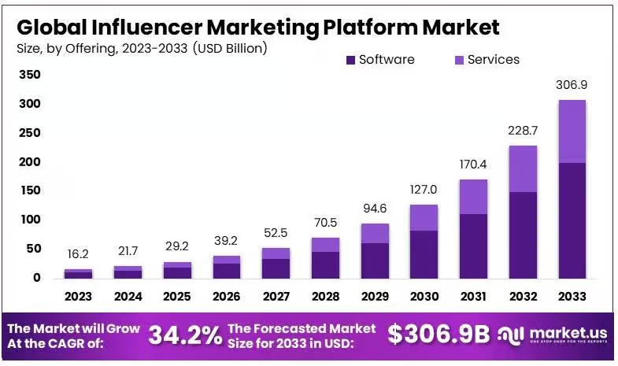
Figure 1: Influencer Marketing market size and forecasted till 2033
(Source: Market.us, 2024)
Gucci is one of the premium luxury fashion brands that have been actively using the smart marketing strategies in order to keep the customers connected as well as strengthen the brand awareness. As per Lu (2024) the Gucci sales reached 10.1 billion euros by 2023 due to strong marketing strategies on the social media platform that increased the purchasing behaviour of customers by 26.98%. The study also revealed that online advertisements contributed to 92% of Gucci's sales in 2020 highlighting the increasing effect of smart platforms on consumer habits. Moreover, 46.03% of the customers came across the Gucci products through online platforms majorly contributing towards the awareness of the product in the market (Lu, 2024). There is an abundance of scientific research on the implementation of influencer marketing in the fashion retail industry; however, little is known about the simultaneous impact of influencer marketing on both purchase intention and brand perception in the case of luxury brands, such as Gucci. Hence, Gucci seems to be the appropriate setting to explore how digital influence is utilized within the luxury goods sector.

1.3 Research Rationale
The change in the consumer purchasing decisions emphasized on marketing share of the company to enter into agreements with influencers as well as the marketing through social media platforms. According to Jamali (2024), it is essential to communicate with the digital platform in the contemporary market environment since it may influence not only the brand image but also the purchasing decisions of the consumers. The importance of the research depends on how luxury brands are increasingly implementing the digital platform at present in order to create relationships with customers and increase brand value. As stated by Gao, Xu, and Yan (2023), luxury brands are increasingly paying attention to the digital marketing strategy in order to enhance customer experience due to the changed market conditions. Therefore, the research paper intends to address the gap which exists between the influencer marketing and purchasing behaviours of the customers. In terms of academic contribution, the research will contribute to the literature on the topic of the influencer marketing strategy since the decision making with regard to the premium product differs significantly from the mass market due to the uniqueness of the product. The findings of the research will be useful for Gucci to understand the purchasing decision of the customers and further develop the marketing strategies to maintain the brand image.

1.4 Research problem
The luxury fashion market has seen great transformation over the past few years along with the use of digital technologies as well as social media channels. Customers increasingly change their buying decisions as per the reviews and recommendations given by the social media influencers. However, there is still no clear evidence in order to understand the effect of the influencer market on the buying decisions of the customers. Gucci is one of the world's famous luxury fashion brands that uses “digital transformation” in order to stay competitive in the changing market. According to Zhou (2024) the success of the brand depends upon its capacity to adjust as per the changing needs of the consumers by using new marketing strategies as well digital connections. Likewise, Wu (2022) states that digital marketing has a great impact on the purchasing behaviour of Gucci's target markets including young luxury consumers. Moreover, Zhang (2025) states that the luxury brands are increasingly using their online strategies as well as digital communication programmes in order to attract the customers that need customized experience. Most academic studies have examined influencer marketing within the fashion and luxury industries without investigating the combined influence of influencer credibility, influencer-generated content, and social media engagement on purchase intention and brand perception among Gucci consumers in Britain. Furthermore, scholars continue to debate whether influencer marketing promotes long-term purchase intention or simply encourages temporary consumer engagement.

1.4 Aims, Objectives & Questions

1.4.1 Research Aim
To examine the impact of influencer marketing upon consumer purchase intention and brand perception towards Gucci products within the UK luxury fashion market.

1.4.2 Research Objectives
- To examine the link between the credibility of influencers and consumers' intentions to buy Gucci products in the United Kingdom.
- To explore the influence of influencer marketing on the perception of the Gucci brand by the consumers.
- To find out the role played by social media engagement in the development of consumer trust and intentions to buy Gucci products.

1.4.3 Research Questions
- How can the credibility of influencers influence consumers' purchase intentions regarding Gucci products in the United Kingdom?
- How does influencer marketing impact consumers' perceptions of the Gucci brand?
- How does social media engagement impact consumer trust and purchasing behavior regarding Gucci products?
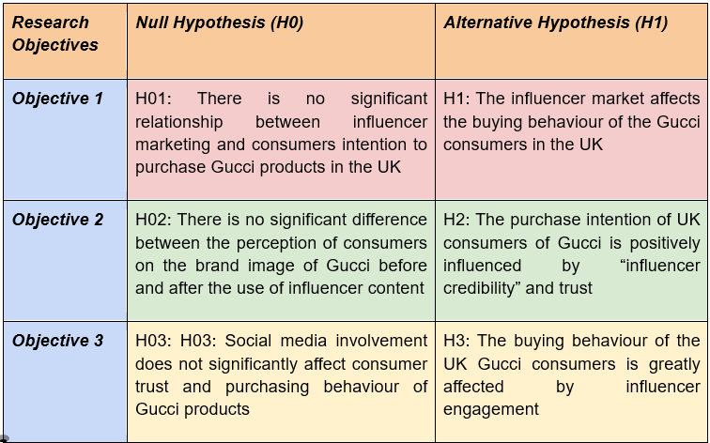
Table 1: Hypothesis development
(Source: Self-created)

1.5 Research significance
The research is significant socially as it examines the effect of influencer marketing on the purchasing behavior of the consumers of Gucci. The rising demand of social media has shifted the consumers to take their advice before buying the products. Practically this knowledge helps the brand to know about their customers so that they could create good connections among them. The study will focus on the influencer marketing with its effects on the customers to provide knowledge for Gucci. The managerial perspective focuses on the company to start campaigns which could involve the consumers required to build long term success of the brand in the fashion market. Moreover, the research will contribute to the development of the literature on the influencer marketing strategy in regard to the UK luxury fashion industry. In terms of managerial contribution, the research findings will be beneficial for luxury marketers to choose the right influencer and create better engagement strategies.

1.6 Research Gap
In general, the research is targeted towards the consumer market, while little attention is paid to the impact of the influencer marketing on the consumer of Gucci. There is a lack of research exploring the impact of three different factors including "influencer credibility", "influencer-generated content" and "social media engagement" on the purchasing behavior of the customer. The above-mentioned variables were investigated separately in the literature, but there was no research devoted to their collective impact.

1.7 Scope of the Study
The study mainly focuses on the consumers of Gucci that highlights the effects of the influencer marketing towards the consumer of the UK. It highlights the effects of “trust”, “credibility” as well as “engagement” of influencers on the buying behavior of the consumers. Socially the study focuses on a specific group of consumers who are aware of the brand as well as those who are active on social media platforms. Geographically it focuses on the market of the UK whereas academically it highlights the influencer marketing. In this study the various other brands as well as the “traditional marketing” strategies are not discussed much. This study is restricted to Gucci consumers in Britain who actively use social media platforms. Consequently, the findings may not be generalizable to consumers of other luxury brands or individuals residing outside the UK.

1.6 Summary of upcoming chapters
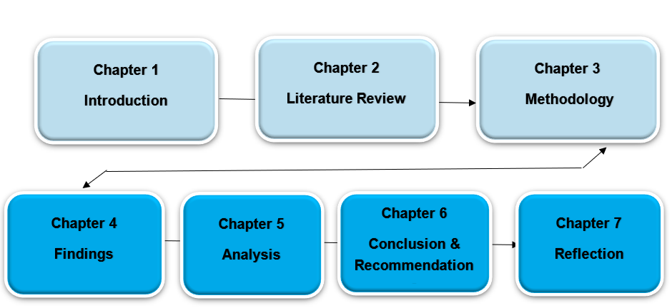
Figure 2: Summary of upcoming chapters
(Source: Self-created)
In Chapter 1 this research will focus on the aim, objectives research questions will be highlighted. Chapter 2 critically analyzes the theories along with the review of literature. Chapter 3 will focus on the research methodology which includes the collection of the data as well as research techniques. Chapter 4 provides the findings of the research that includes the results of the study followed by chapter 5 that compares the results with research goals. The last chapter 6 will focus on the conclusion as well as recommendations that could help to build a successful company. And chapter 7 presents the final reflection upon the researching process for completing the dissertations.

Chapter 2: Literature Review

2.1 Chapter Introduction
The current chapter reviews the relevant literature critically, which are appropriate to influencer marketing along with its impact on the intention of consumer purchase intention within the industry of luxury fashion. The review also examines academic research industry reports, policy documents along with the theoretical perspective that is associated with digital transformation, luxury branding and influential marketing. Special attention has been given to the digital marketing practices of Gucci and the theoretical foundation has underpinned the effectiveness of influencers. The chapter, therefore identifies inconsistencies, gaps and research and also important debates which justify the need for investigation within the luxury fashion market of the UK.

2.2 Policy & research, Published & grey ‘literature’
According to Cartwright et al. (2022), the importance of influencer marketing is growing, and it has also attracted important attention from the practitioner, policy makers and academics. The literature that has been published focuses mainly on understanding how the authenticity, engagement on social media, and credibility of the influencers is creating a significant impact on the behavior of consumers. As per Xu (2023), influencer marketing is capable of enhancing the brand awareness and intention of purchases in a more effective manner compared to traditional advertising. This is because consumers most of the time perceive the influencer as trustworthy and relate to products and brands. However, such extent associated with this type of influence also remains debatable, especially within the markets of luxury fashion where prestige and exclusivity, both are the main central values of the brand.
The grey literature like the consultancy publications, social media analytics, and industry reports has become influential for understanding the practices of contemporary influencer marketing. It has also been found that there is a growing investment made for the influential collaborations by the fashion brands which are luxury in the market (Syed et al., 2023). The literature also prioritizes the commercial outcomes as well as practical insights often over the reliability of academics and methodology. Collier et al. (2022), argues that the development of policy has also created a significant influence over the marketing practices of the influencer regulatory bodies like Advertising Standards Authority (ASA) of the United Kingdom. This has also introduced guidelines which are required for transparency in any sponsored content. In spite of the fact that most academic research proves the effectiveness of influencer marketing, the grey literature pays more attention to commercial issues than to methodological ones. This difference can be the cause of inconsistency in the existing literature and, thus, requires additional research based on empirical evidence

2.3 Key Definitions

2.3.1 Definition of Influencer Marketing
Influencer marketing is defined as an approach that is strategically promotional in which the brands make collaborations with individuals who have a substantial following in the social media. Compared to the traditional way of celebrity endorsement, the reliability of influencer marketing depends heavily on interpersonal relationships, content engagement and perceived authenticity (Leite et al., 2024). The influence has also acted as an intermediary between the consumers and brands through creating content that contains the messages that is done through the daily interactions in social media (Chen et al., 2024). On the other hand, Duffek et al. (2025) argues that the influencer acts as an agent of commercials whose recommendations are important as it is being driven by the financial incentive, primarily rather than any advocacy of the product genuinely.

2.3.2 Evolution of Influencer Marketing
There has been a broad transformation in consumer behaviour and digital communication, which is being reflected by the development of influencer marketing. Earlier influencer marketing has been associated with the endorsement of celebrities through the help of public relation campaigns, print media and television (Akande and Akin-Odukoya, 2025). The emergence of social media platforms, however, has significantly changed the interaction of brand and consumers through enabling a direct engagement between the followers and the influencers (Kim and Kim, 2022). The rise of the social media platforms like YouTube, TikTok and Instagram has significantly facilitated micro influencer’s emergence along with niche content creators (Adefemi and Mutanga, 2025). This type of shift has also enhanced the effectiveness of the market as consumers are becoming the individuals who are relatable to trust. It has also been evaluated that there has been an evolution from a relationship-based communication strategy into an advertising ecosystem, which is digitally sophisticated. Therefore, the increasing commercialization might also give us the trust of consumers which highlights a serious tension within the influencer marketing in the contemporary period. In spite of the rising popularity of influencer marketing in the modern business environment, scholars have disagreements on what makes it effective: the authenticity or commercial visibility. The ongoing dispute demonstrates that the explanation of influencer effectiveness is far from being established.

2.4 Luxury Fashion Industry and Digital Transformation

2.4.1 Luxury Fashion Marketing & Digitalization
According to Liu and Liu (2025), a major digital transformation has been seen in the luxury fashion industry over some period of time in a decade. Earlier, the luxury brands were more dependent on channels for recognition, communication and scarcity. The advancement of digital technologies along with the changes in the behaviors of the customers have provided encouragement to the luxury brands to use the strategies of online marketing (Khan et al., 2022). New opportunities have also been created by digitalization for the engagement of customers with the help of e-commerce channels, personalized digital experiences, and social media platforms. Digital marketing is an effective way to connect with GenZ consumers as they are more prone to utilize social media for information. Apart from that, social media even impacts the purchasing decision and delivery of the products. Still, there is a debate regarding weather, the accessibility of digital platforms reduces the exclusivity that is linked with the consumption of luxury products.

2.4.2 Gucci's Digital Marketing Strategy
Gucci is a well-known luxury fashion brand in the world, which has successfully implemented digital innovation. The company has used influencer collaboration, digital marketing and social media successfully in its strategy of marketing, which helped in improving the consumer engagement and visibility of the brand (Lu, 2024). The digital success of Gucci comes from the combination of the techniques of modern digital communication with the luxury heritage. It may be stated that working with the fashion influencers, content, creators and celebrities has facilitated the company to increase its reach towards a segment of young consumers (Jhawar et al., 2023). It is also argued that such types of strategies are only effective when there is a consistency that remains in the content of influencer with the identity of the brand. This hints towards the risks which are associated with extensive involvement with the influencer partner partnership. Additionally, too many promotions might also reduce the exclusivity of the brand which impacts the authenticity of the luxury products (Wang et al., 2024). Overall, existing studies indicate that digital transformation provides luxury brands with new ways to increase customer engagement and at the same time poses new challenges related to the maintenance of brand exclusivity. Thus, luxury brands have to maintain the balance between accessibility and premium status.

2.5 Theoretical Foundations
The four theories used in this research help to reveal different aspects of influencer marketing. Source Credibility Theory reveals the dimension of trust, Source Attractiveness Theory covers the aspect of persuasive appeal, and Social Influence Theory deals with peer influence, while the Theory of Planned Behavior explains how these aspects influence consumers' purchase intentions.

2.5.1 Source Credibility Theory
Source credibility theory is a framework that is used for understanding the effectiveness of influencer marketing. The theory was developed by Weiss and Hovland in 1951, which explains that the effectiveness of communication mainly depends on the perceived credibility of the source of the information (Ciunova-Shuleska, 2022). The measurement of credibility is usually done through trustworthiness, reliability and expertise.
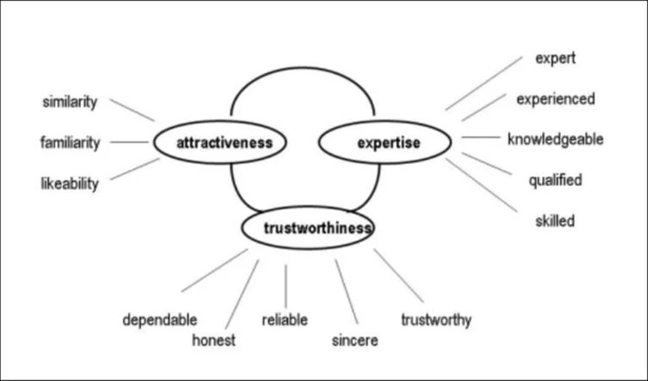
Figure 3: Source Credibility Theory
(Source: AI et al., 2024)
It has been found that there lies a positive link between the purchase intentions and influencer credibility, especially during the time when influencer has expertise in any particular categories of product (Sesar et al., 2022). It has been argued by Helme (2023) that influencer credibility is often quite highly contextualized and might not change across product categories which might create perceived credibility that barely reflects genuine expertise. This becomes important in luxury fashion as purchasing any luxury product involves the psychological and financial risk often. It is also found that credibility as an individual might not be enough for influencing decisions. In addition, the excessive promotional content along with commercial sponsorship has the ability of reducing trustworthiness. Source Credibility Theory supports the first research objective by demonstrating how an influencer's expertise and trustworthiness shape consumers' intentions to purchase products.

2.5.2 Source Attractiveness Theory
Source Attractiveness Theory evolves persuasion research while putting more effort on likeability, similarity and physical attractiveness which are the major factors for impacting consumer behavior. According to the theory, it is believed that people are likely to be persuaded by those kinds of communication which they find easy and attractive and are able to relate with it. Attractiveness is not only limited to the physical appearance in influential marketing as it includes characteristic, personality, lifestyle, appeal, and also aspirational qualities (Wolfe and Patel, 2024). Alinikula and Larsson, (2025) argued that too much dependency on influencer attractiveness could damage authenticity while increasingly differentiating between genuine recommendations and aesthetically fostered promotions and hence lowering long term brand trust.
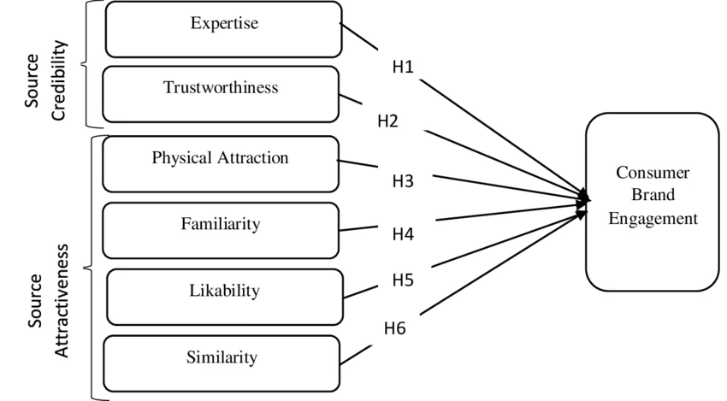
Figure 4: Source Attractiveness Theory
(Source: Duh and Thabethe, 2021)
This is effective for creating strong emotional connections and brand appeal with the audience that has been targeted. The supporters also believe that influencers who are attractive are responsible for increasing the engagement of consumers along with purchase intention and customer attention (Ao et al., 2023). However, it is also argued that giving much focus on the attractiveness might be the reason for authenticity reduction. Therefore, the source attractiveness theory also needs to be considered with various other factors that create an effect on the decision-making process of the consumers. Source Attractiveness Theory contributes to this objective because attractiveness alone is insufficient to encourage purchase intention without consumer trust.

2.5.3 Social Influence Theory
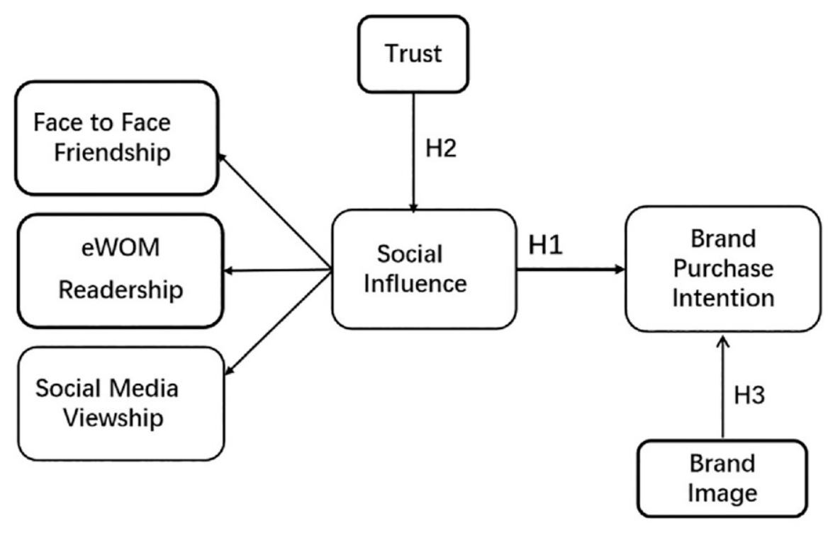
Figure 5: Social Influence Theory
(Source: Liang et al. 2024)
Social influence theory highlights that the behavior, thoughts as well as attitudes of the people are affected by the other people around them. When the customers are not sure regarding any product their opinion depends directly upon the viewpoint of the other people. Lim (2022) suggests that social media is an important factor that influences the consumer buying behavior towards a particular brand. Hu and Zhu (2022), argued that the impact of social media on consumers is not stagnant but it differs a lot in terms of critical thinking, prior brand loyalty along with skepticism in terms of sponsored content that might limit the persuasive power of influencer recommendations. The increase in social media trends have made the customers dependent upon the social content on a daily basis.
Hence, the Social Influence Theory is a framework that helps to understand the effect of influencer marketing on maintaining the brand image as well as the success of Gucci products among the consumers of the UK market. In contrast, Social Influence Theory emphasizes collective social influence rather than individual influencer characteristics. This suggests that purchasing decisions are influenced not only by the attributes of influencers but also by broader social interactions and peer networks.

2.5.4 Theory of Planned Behavior (TPB)
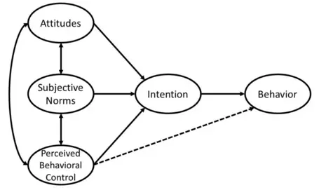
Figure 6: Theory of Planned Behavior
(Source: Sansom, 2021)
The figure above represents theory of planned behavior which is a combination of attitudes, subjective, norms, perceived behavioral control which impact intention and finally behavior. The theory of planned behavior developed by Ajzen is an established theoretical framework that can help to gain insights into the effect of influencer marketing on consumers' purchase intent. This theory proposes that an attitude towards the behavior, subjective norms, and perceived behavioral control are three factors that impact a person's behavioral intention. In the context of influencer marketing, the information provided by the influencers creates positive or negative attitudes of consumers towards the product.
Social norms developed through Instagram influencers have important effects on the purchase intention of the millennial because Instagram followers follow the influencers as trusted sources of advice and lifestyle (Madsen and Mbuyi Tshibangu, 2023). TPB has been really important in the context of luxury fashion brands like Gucci, where consumers' personal attitudes and social influences play a role in their buying decisions. However, TBP has been criticized for assuming that customer behavior is always rational as well as planned. Madsen and Mbuyi Tshibangu (2023) showed that trust as well as perceived risk have important roles in impacting purchase intentions of customers in influencer marketing contexts. TPB has offered a detailed description of the impact evaluated by other theories into behavioral intention, hence making it particularly eligible for explaining purchase intention towards Gucci products.

2.6 Themes

2.6.1 Theme 1: Influencer Credibility and Consumer Purchase Intention
It is proposed that the credibility of the influence is considered one of the important elements that affect the purchasing intentions of consumers in digital marketing. It is believed that the credibility consists of such components as the expertise, reliability, authenticity and attractiveness which can affect the perceptions of consumers about the promotion message. According to Hamedani et al. (2025) the acceptance of brands by consumers will take place when influencers are considered knowledgeable and authentic by consumers. It means that the trust will affect the attitudes of consumers about the product which, in turn, results in purchasing intentions of consumers in fashion industry. Moreover, Benichou and Maindron (2024) note the increasing role of social media influencers as the important element of the luxury fashion industry especially in case of Generation Z customers. It is believed that the genuine endorsement by influencers helps to increase the emotional attachment to the luxury brand and purchase intentions of consumers. Concerning the luxury fashion industry, both the product itself and the credibility of the influencer in terms of the social proof and fashion influence the decisions of consumers. In this case, Duffek et al. (2025) note that the inauthenticity and the heavy sponsoring of the product may reduce the level of the trust that decreases the effectiveness of the endorsement among consumers.
Nevertheless, the effectiveness of influencer credibility greatly depends on its authenticity and transparency. In spite of the positive effect of influencer credibility on purchase intention described by the existing literature, many scholars state that the authenticity and transparency are just as important as credibility in building trust of consumers.

2.6.2 Theme 2: Influencer-Generated Content and Brand Image
Content created by influencers has been an important component in the marketing mix of any fashion brand. Influencer-generated content is more personal, interactive, as well as relatable, which gives customers the opportunity for realistic experiences and recommendations, which are not found in local advertisements. As given by Chen et al. (2024), influencer marketing has a crucial role in impacting consumers’ purchase intentions, which acts as a role of brand awareness, brand association attributes, and also consumer positive attitude towards the product. Social media becomes a channel for influencers to show products used in daily life, which helps to increase the appeal and approachability of brand messages to consumers. The study of Magano et al. (2022) showed that being positive towards influencers of fashion is a connector between brand and customer. It also highlights that 95.4% of users follow the use of Instagram and 91.2% follow influencers. All this data shows the importance of social media contents in impacting the perception of customers. Gucci, a luxury brand, wants to reach younger generation customers through influencer marketing while noting their buying habits.
Nonetheless, the utility of the content created by the influencers has come into question on the part of the consumers globally. According to Duffek et al. (2025), there has emerged the issue of authenticity in connection with the influencers. In this regard, 88% of the consumers believe that authenticity is the important characteristic while dealing with the influencers. At the same time, about half of the consumers find that the influencers lack authenticity, and 35% of the consumers find that the influencers do not have transparency in their posts containing the sponsored content. Hence, this paper concludes that the commercialization is a negative aspect of the brand image when it results in excessive commercialization. In terms of luxury fashion industry where exclusivity and prestige are the important characteristics of the brand, this kind of excessive promotion of the products may not be liked by the consumers.

2.6.3 Theme 3: Social Media Engagement, Trust and Buying Behaviour
Social media engagement has become an important factor impacting consumer trust as well as buying behavior in the digital marketplace. Engagement is what consumers do when they use the internet, which involves linking with content through likes, sharing, commenting and joining in conversations. So, these interactions allow us to build trust and also increase purchasing intention between consumers and both influencers and brands. Active engagement by influencers can improve consumers' feelings of attachment and trust in influencer recommendations, which impacts positive purchase intent, according to Ao et al. (2023). The importance of engagement is confirmed by the findings of Liang et al. (2024) which show that social influence, brand image are important factors in impacting purchase intent. According to their study, 36.2% of social network users have tried products recommended by an influencer, with 92% following (at least one) influencer and 20.4% buying products based on the recommendation from their influence. Also, Kim and Kim (2022) argue that many of consumers' assumptions about influencers are that they can offer the audience advice and recommendations that can be trusted and that they are human beings that are accepted as normal in society.
The connection between social media engagement and purchasing behavior is rather complicated. Liang et al. (2024) point out the role of the family, friends and the social network of consumers that affect the decisions of consumers. Despite the fact that consumers are engaged in social media, it does not guarantee consumers' purchases because social media is used by consumers for entertainment. As it has been already mentioned, the engagement of consumers in social media increases the level of trust but it does not result in consumers' purchasing behavior because consumers are influenced by some other psychological factors.

2.7 Influencer Marketing in Luxury Fashion Brands
As the luxury fashion industry tries to reach the target digitally active audience, the influence marketing system has grown in importance with the passage of time. In the study conducted by Benichou and Maindron (2024), it is shown that influencers have a huge impact on the purchase intention of GenZ consumers to luxury fashion. Micro-influencers make more emotional impact than larger influencers because they are seen as more authentic and relatable, their survey of 102 people found. These results show that influencer marketing helps to improve brand awareness, consumer engagement, as well as purchase intention.
Exclusivity, prestige and rarity are luxury brand strengths whereas social media promotes making it accessible and communicating with everyone. According to Benichou and Maindron (2024), excess marketing strategies such as influencer marketing can challenge the luxury image of a brand. Also, Duffek et al. (2025) propose that the public is growing more and more suspicious towards relationships that are seen as too commercial. Although influencer marketing is widespread, scholars continue arguing whether the broad collaboration with influencers increases or decreases the exclusivity of luxury brands.

2.8 Gap in the knowledge
While there are many studies that have looked at the role of influencers in marketing, some gaps in the literature do exist. Research on this topic to date mostly highlights the general consumer market or the specific market, such as young gen Z consumers in France (Benichou and Maindron, 2024). Moreover, there is no study that examines the effect of the credibility of influencers, social media engagement and the generated content of influencers collectively in terms of Gucci brand in the UK market. Therefore, the purpose of the dissertation is to fill the gap in theoretical research. In addition, there are many studies that examine the credibility of influencers, the engagement in social media as well as the generated content of influencers individually but not in terms of purchase intention.

2.9 Conceptual Framework
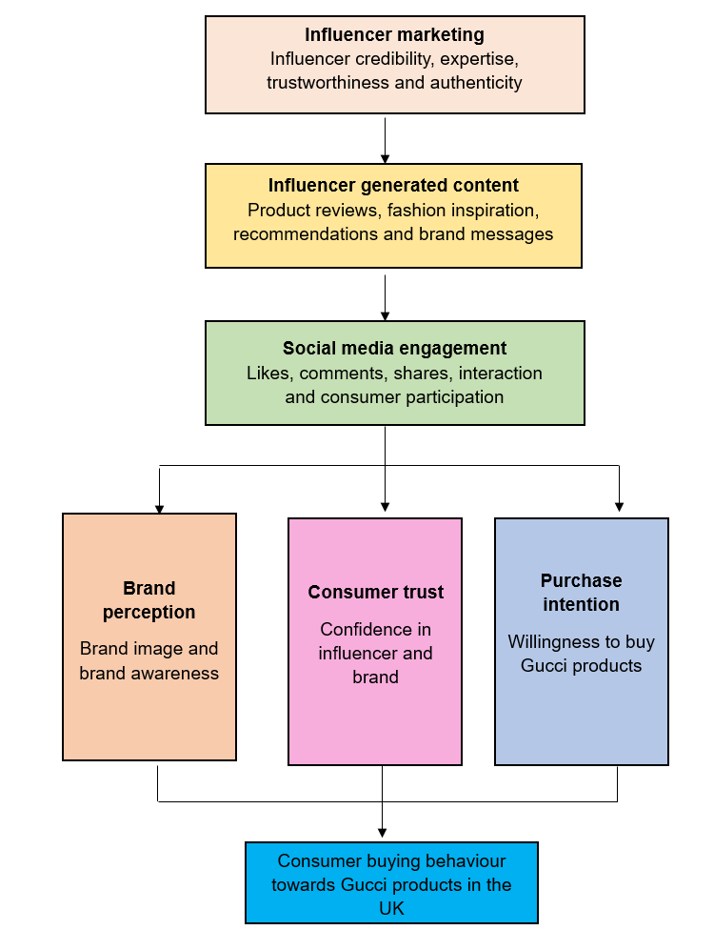
Figure 7: Conceptual Framework
(Source: Self-created)
In the suggested conceptual framework, the credibility of influencer, the content generated by influencer, and social media engagement are the independent variables. The purchase intention serves as the dependent variable, while brand perception serves as the explanatory one.

2.10 Summary
The chapter focused on the impact of the influencer marketing that affects the shopping behavior of the consumers as per the social media trends. According to this article the influencers are increasingly becoming the main factors in uplifting the brand image as well as the brand success globally. It also highlights the research gap that focused on the consumers of the Gucci products of the UK which formed the base for the next step of this research. Overall, the literature depicts several notable inconsistencies within the effectiveness of influencer marketing, thus depicting the need for more investigation in this research study.

Chapter 3: Methodology

3.1 Introduction
In this chapter the brand image as well as the buying behaviour of the consumers towards the Gucci products in the UK have been discussed by using the research methodology in order to study the effect of the influencer market. The methodology has been selected on the basis of research aim as well as objectives discussed in Chapter 1 and also to fill the research gaps of Chapter 2. On this proposed plan, a primary quantitative approach has been used as it allows the collection of data from the Gucci consumers that help to statistically analyse the relationship between the content created by the influencers, social media engagement, reliability of the influencers as well as purchase intention. The chapter explains the research approach, research strategy, selected research philosophy, data collection methods, time horizon, data analysis techniques, validity, ethical consideration, reliability and methodological limitations.

3.2 Research Philosophy
As per Bayuo et al. (2025) research philosophy is the collection of beliefs about the process of developing and understanding knowledge in a research investigation. It is very important to select the right research philosophy because it highlights the manner in which the research data is gathered, designed as well as analysed. The research philosophy differs in the assumptions of the existence of knowledge as well as reality which includes interpretivism, positivism, pragmatism as well as realism. In this the positivism research philosophy is selected as the study test existing theories instead of creating a new theory. According to Bell, Bryman and Harley, 2022 the observable evidence helps in identification of the relationships as well as pattern of the social phenomena by using statistical methods. It is appropriate to measure objectively as the study is designed to study the effect of the three variables that are influencer credibility, social media engagement as well as influencer generated content on the purchase intention of Gucci products.
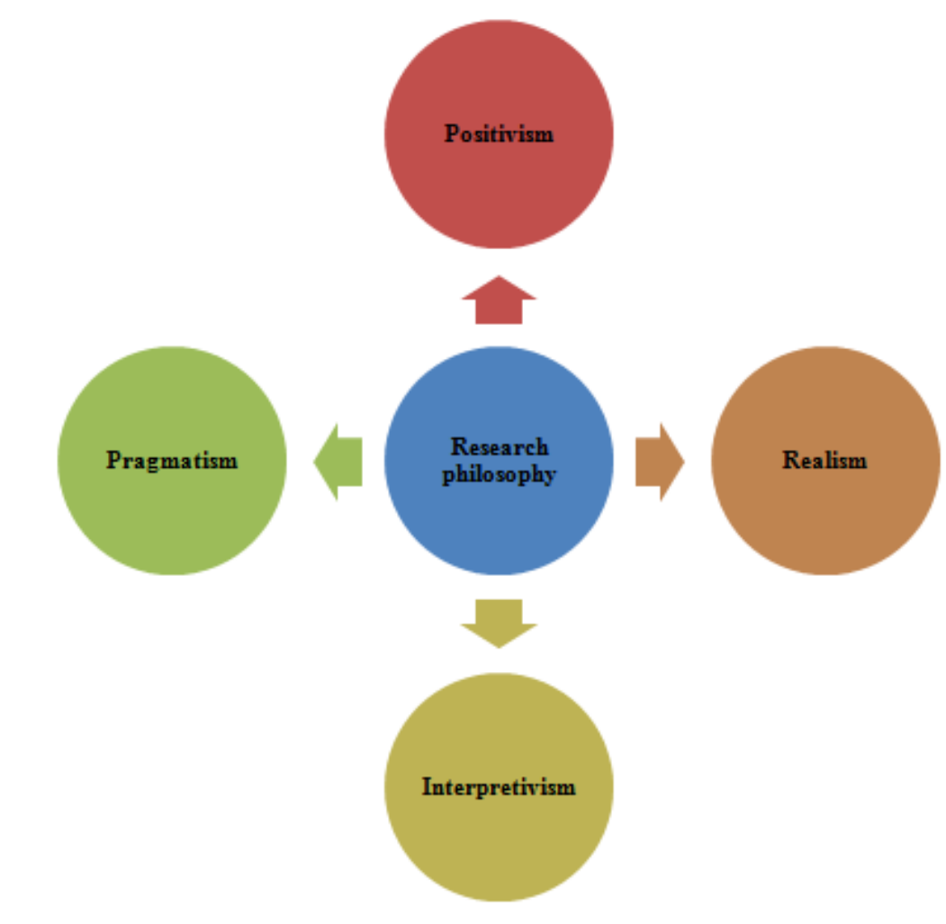
Figure 8: Types of Research Philosophy
(Source: Sathibabu et al. 2022)
As per Maretha (2023) a positivist philosophy is useful for this study as the quantitative research design will allow the researcher to obtain data from the participants by reducing the researcher's bias and making the research more reliable. The data collected through the standardized questionnaires also helps the researcher to analyse the relationship between the research variables by comparing the results of the previous research on influencer marketing. As per Zait (2025) in contemporary marketing research the consumer’s intentions as well as attitudes are measured through structured survey tools. Many other philosophies were also taken into consideration but were not selected as they were not suitable for the present research. According to Pervin and Mokhtar (2022) the interpretivism philosophy is more useful instead of hypothesis testing as it involves the understanding of the people's experiences by observation as well as interviews. According to Saputri (2024) realism philosophy focuses on the subjective as well as objective realities but it has very complex mixed research designs. As per Elgeddawy and Abouraia (2024) the pragmatism philosophy involved the mixing of the qualitative as well as quantitative approach but as the study has its objectives this is not appropriate to adopt in a more complex mixed approach. Positivism seems to be very relevant for the current research as the study tries to test some hypotheses regarding the relationship between the credibility of an influencer, brand perception, social media engagement, and purchase intention. All of these factors could be measured, with the help of objectives through questionnaires and statistical analysis. As the purpose of the research is to prove the existence of these relationships and not to understand the personal experience, the philosophical paradigm seems to be more appropriate for the current research.

3.3 Research Approach
The research approach is a logical way in which the knowledge is developed by balancing theory with empirical evidence. There are three types of research approaches which are deductive, inductive and abductive. According to Kumar and Ujire (2024) the deductive research approach includes the hypotheses as well as theories that are tested using the empirical data whereas the inductive approach includes the theories generated from the observations. As per Janiszewski and Van (2022) the abductive research method is a combination of both deduction and induction which is used by the researchers to explain the results that they have found in their research. A specific research approach is selected on the basis of research design, research objectives as well as the type of data that will be gathered. The research approach selected in this study is deductive research approach as the research highlights the effects of influencer marketing on the consumer purchase intention as well as brand image towards Gucci products in the UK. The deductive approach has been chosen in the study because the hypotheses were formulated based on the Source Credibility Theory and the Theory of Planned Behavior before gathering data. No theories are developed during the process of research and the confirmation of the existing ones among Gucci customers in the UK is required.

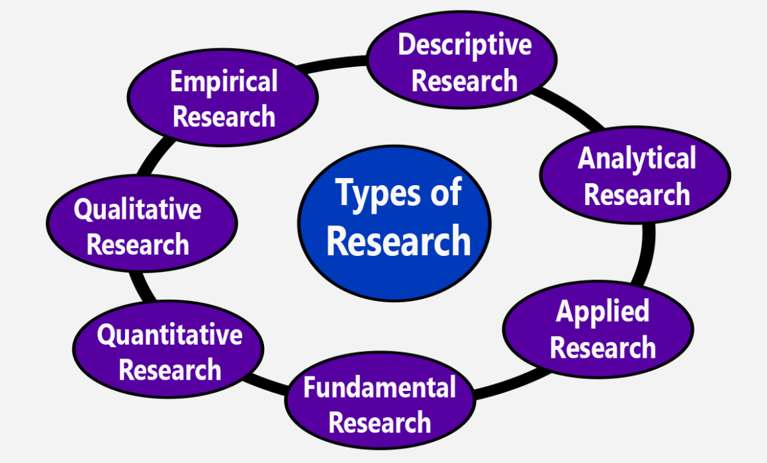Figure 9: Types of Research approach
(Source: Haruna Ar Rashid, 2019)
The primary data will be gathered with the help of structured questionnaires measured by 5-point Likert scale having close ended questions. The statistical analysis of the responses will help the researcher to find out the relationships that exist between the influencer generated content, reliability of influencers, consumer trust, social media involvement as well as purchase behaviour. Numerical analysis is very important for objective hypothesis testing as it improves the reliability of the results. As per Sinaga et al. (2023) the inductive approach results in the development of new theories rather than testing existing ones but also provides the information of the people's experience resulting in a qualitative interviewing process. Similarly, the abductive approach involves researchers to move between theory and observation but it is more appropriate for explorative studies that involve mixed methods (Kistruck and Slade, 2022). The above research approaches would make the methodological consistency less in the current study as the objectives, hypotheses and theoretical construct have been pre-defined.
Hence, the deductive research approach is the most suitable method to study the effectiveness of influencer marketing on Gucci consumers in the UK.

3.4 Research Strategy
The systematic way of collecting and analysing data to solve the research questions is research strategy as per Bayramova and Edwards (2026). A survey strategy will be used to study the effect of influencer marketing on the consumer purchase intention towards Gucci products in the UK. The survey method was considered to be suitable for the existing research in order to obtain the information from a great number of Gucci customers within a relatively short period of time. Also, the usage of structured questionnaires offers an opportunity to carry out the statistical analysis with the help of the SPSS program. The participants will fill an online questionnaire form that will include questions as measured by the five-point Likert scale ranging from Strongly Disagree to Strongly Agree.
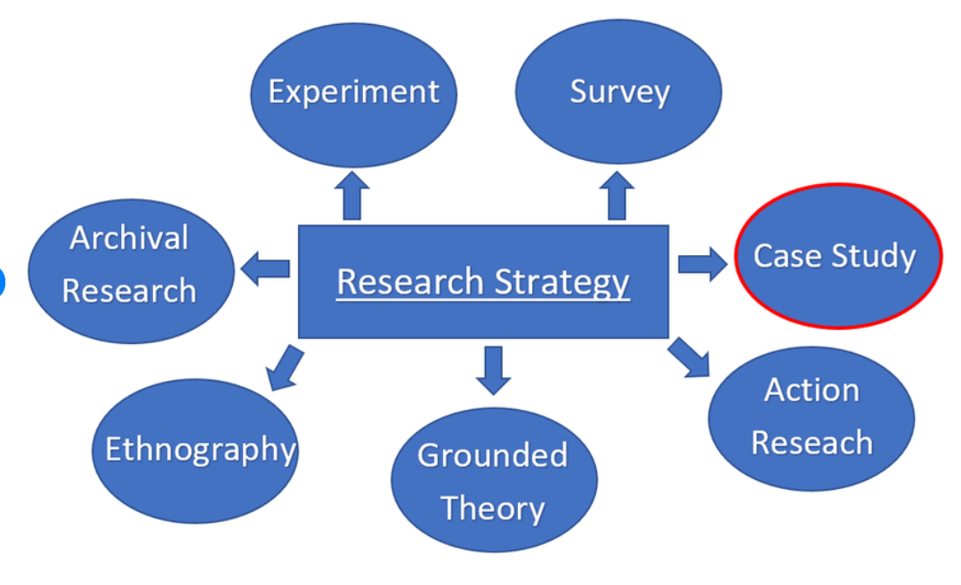
Figure 10: Types of Research strategy
(Source: Talmatchi, 2020)
According to Chen et al. (2022) it is important to choose a survey strategy as the target population consists of Gucci consumers which use social media such as Instagram and YouTube. The data from geographic groups of people could be collected by online surveys thus avoiding time as well as financial limitations. The respondents remain anonymous in the surveys making statements more reliable. However, there are some drawbacks such as the questions could prevent the participants from putting forward their opinions. Hence the survey method seems to be more reliable on the basis of research objectives that will answer the research hypotheses.

3.5 Data Collection Methods
The study uses a primary quantitative data collection method as it is designed to validate the correlations among variables that were already identified, such as influencer-generated content, influencer credibility, brand perception, social media engagement and purchase intention. As per Kircher and Zipp (2022) quantitative data helps the researchers to reduce the research bias by providing objective evidence to the research questions as well as comparing the data statistically with the respondents. The primary data will be collected with the help of the online questionnaire in Google Forms. The questionnaire is an easy method of collecting responses from a relatively large number of respondents within a reasonable time frame and budget. As per Ha (2022) the online surveys in marketing research are most commonly used due to the minimum data entry cost as well as administrative costs.
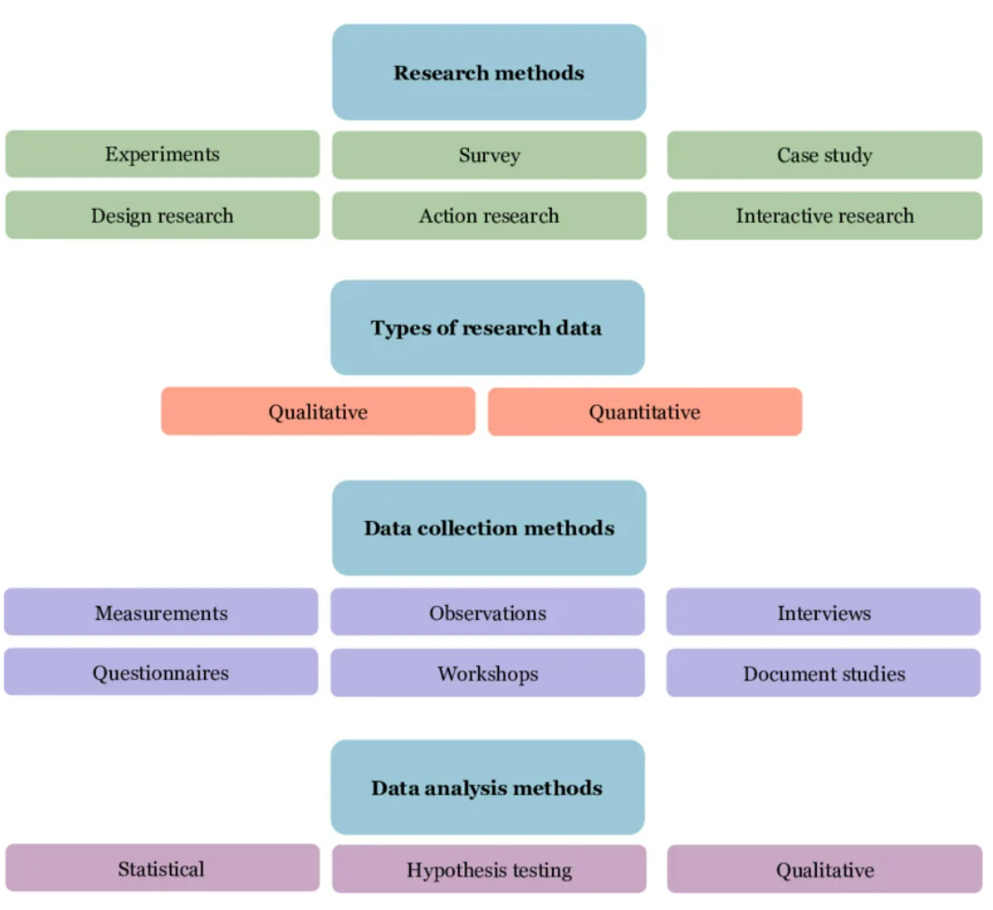
Figure 11: Types of Data Collection Techniques
(Source: Drego, 2024)
The survey will have questions that will be scored primarily by the five-point Likert scale from Strongly Disagree (1) to Strongly Agree (5) consisting of the two parts. The demographic data includes the usage of social media, age education as well as gender whereas the second part includes the social media engagement, influencer generated content, consumer trust as well as brand image. The target audience consists of UK consumers having knowledge about the Gucci products using social media platforms like Instagram, YouTube and Facebook. The convenience sampling method has been used for the following reasons. Firstly, the target population included Gucci customers who lived in the UK and used social media actively. The publicly available sampling frame of Gucci consumers did not exist; therefore, there was no chance to conduct probability sampling. Thus, the convenience sampling made it possible to reach the target population in terms of time and resources. It should be noted that the sample of about 100 respondents was sufficient as the number of observations was enough for descriptive and statistical analysis. In order to minimize the sampling bias, the questionnaire was distributed on different online platforms instead of only one social media group. The screening questions made sure that the only people who were familiar with Gucci products took part in the study.

3.6 Data Analysis Methods
As per Saunders et al. (2019) the study focuses on studying the relation between the influencer marketing and consumer buying behaviour towards Gucci products in the UK therefore the analysis of the collected data will be done by using quantitative statistical techniques. According to Olivar et al. (2024) quantitative data analysis will help the researcher to understand the patterns as well as trends leading to replicable results. The numerical analysis gives more accurate results as it focuses on the credibility of the influencers, social media involvement as well as consumer perceptions which are not measured by qualitative methods. The responses will be coded and entered to the Microsoft Excel thereby transferring to IBM SPSS Statistics for statistical analysis. The excel will help in data coding as well as checking missing values whereas SPSS will be used to run more complex statistics that will increase the reliability and validity of the findings as stated by Field (2024). The incomplete questions will be removed before analysis in order to improve the data quality and the remaining responses will then be coded.
The analysis will include descriptive statistics involving percentages, standard deviations, mean value as well as frequencies. The demographic variables will be written in table format, pie charts as well as bar charts highlighting the consumer characteristics as well as their attitude towards the influencer marketing and Gucci products. This will highlight the research objectives by studying the behaviour of consumers before examining the statistical relationships. The second step includes the inferential statistical analysis where ANOVA testing will be done. According to Karunasingha and Abeysekera (2022) Pearson's correlation analysis is performed to analyze the strength and direction of the relationships among the social media engagement, influencer credibility as well as consumer buying behaviour. Correlation analysis has been conducted using the Pearson coefficient in order to find out the relationship between credibility of the influencer, brand perception, social media activities and purchase intentions. Lastly, reliability testing where Cronbach's alpha will be used to assess the internal consistency of items whose value of >0.70 is considered acceptable as stated by Ahmad et al. (2024).

3.7 Time Horizon
The study uses the cross-sectional time horizon as the data will be collected from the subjects at one time only. The cross-sectional time horizon is suitable as the study analyzes the effect of influencer marketing on the buying behavior of the consumer as well as brand image towards the Gucci products in the UK. According to Mabkhot et al. (2022) the consumer image towards the credibility of the influencer, social media interaction and purchase intention could be measured by using a onetime survey therefore reducing the need to observe the behavioral changes over time. The time frame responses as per the research questions and provide surety of the existence of the relationship between the selected variables. The major drawback of the time frame lies in the fact that it is too short to demonstrate a shift in consumer behavior from the changing marketing efforts.
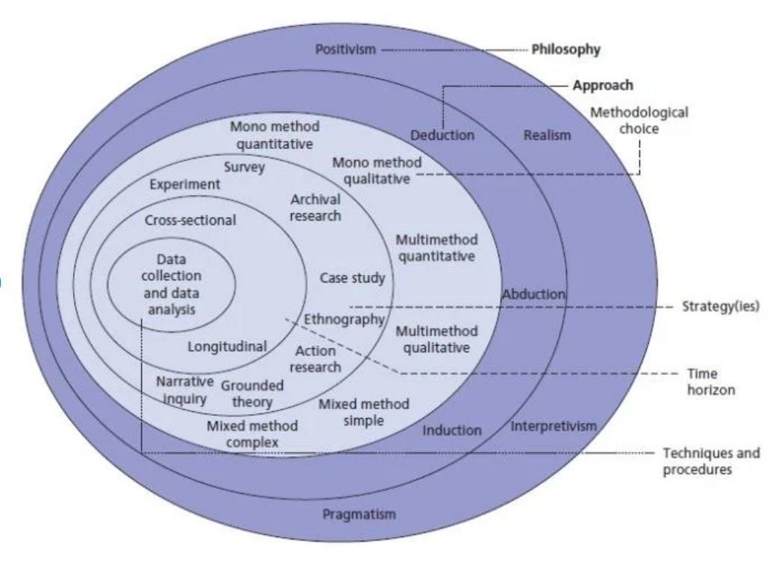
Figure 12: Research Onion
(Source: Rahman, 2017)

3.8 Discussion of the Validity and Reliability of the Primary Data
The question in the survey will be designed on the basis of the measurement items that have been tested in the literature related to the study. Content validity has been provided through development of questionnaire items based on the results of previous literature review and measurement scale. Since there already is an empirical basis for the variables used in other studies, construct validity will be improved in order to make sure that all questionnaires are consistent with the purpose of this research. Construct validity will be enhanced through provision of more than one questionnaire item to measure each construct in accordance with the dimensions created in the previous research. Pilot testing has been conducted including about 15 participants in order to assess the clarity of wording and the time needed to complete the questionnaire. The questionnaire has been modified based on the results obtained during the pilot test in order to improve readability and eliminate any vague questions before the data collection process has begun. Data quality has been ensured through elimination of all incomplete questionnaires, duplicates and missing values. An information sheet has been given to participants in order to provide them with the details on the nature of the research, its duration, voluntariness and confidentiality of the collected information. All participants have signed the information sheet and provided their consent to participate in the research prior to filling out the questionnaire. They could leave the research process before completing the questionnaire. No personal information has been collected.

3.9 Limitations of the Methodology
The selected methodology is appropriate for investigating the research question but has certain limitations such as in the convenience sampling method all the UK consumers of the Gucci do not have the same opportunities to participate in the research. The other limitation is related to the online questionnaire as the internet surveys do not reach the people that are not active on social media. As the research is on influencer marketing the consumers must have some knowledge regarding the social media platforms. Therefore, overexposure of the effect of social media on the buying behavior of the consumer could occur along with sampling bias.
The research focuses on the consumer perception and not behavior which could underestimate the influence of the influencers due to memory failures thereby affecting the actual purchasing behavior. The behavior of people towards influencer marketing is different in different countries due to cultural, economic and social differences. Thus, the results of the research cannot be generalized to other luxury fashion brands as the study particularly focuses on the UK consumers. Lastly, in cross sectional design the data is gathered only once therefore the behavior of the customer to the influencers change quickly due to changing social media trends.

3.10 Ethical Implications
The study will follow ethical standards approved by General Data Protection Regulation (GDPR) as well as De Montfort University followed by an ethical approval. All the participants will receive an information sheet with the aim to explain the voluntary participation, the purpose of the research as well as their right to withdraw from the study anytime. The anonymity of the participants will be maintained by not collecting the personally identifiable information such as names, contact details and email. The collected data will be stored in a secure manner protected by password that could only be accessed and used for academic research purposes. It will not be passed to third parties and will be deleted after completing the dissertation according to university requirements. These ethical procedures maintain the privacy of the participant, improve the credibility of the research findings as well as reduce the research risks.

3.11 Gantt Chart
The Gantt chart was used to plan the research activities as well as to make the dissertation more systematic in the given time. The programme involves the topic, literature review, methodology development, ethical approval, design of the questionnaire and pilot testing. Then primary data collection is done followed by data analysis using SPSS along with interpretation of data and discussion. The last steps include the conclusions, recommendations, proofreading and formatting of the dissertation. This helps in analyzing the progress of the research by providing sufficient time for each activity thereby reducing the delays.
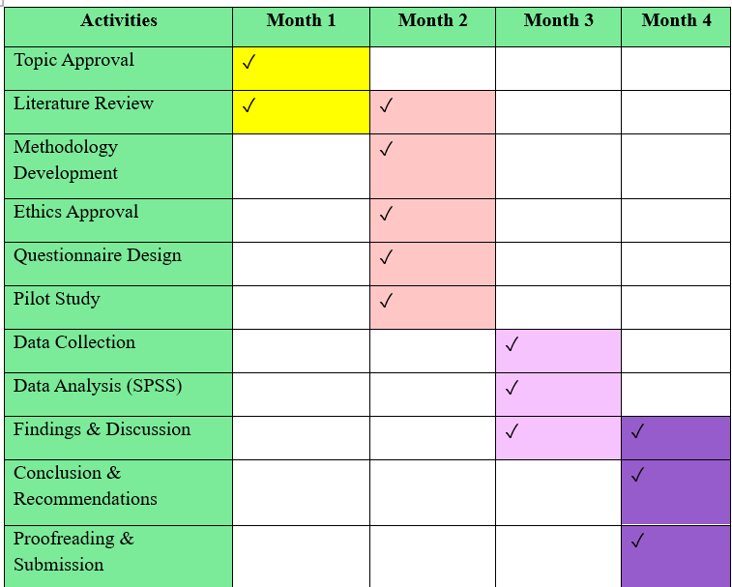
Figure 13: Gantt chart
(Source: Self-created)

3.12 Summary
The methodological framework used for the research of the influence of influencer marketing on the buying behavior of Gucci products in the UK has been described in this chapter. The positivist philosophical approach, deductive research method as well as survey research strategy were chosen because of their systematic approach in examining the hypotheses. The data collected from the online survey will be distributed to the Gucci consumers by using convenience sampling along with SPSS for descriptive and inferential statistical analysis. The procedures in this chapter highlights the validity as well as ethical compliance of the methodology used but with limitations. Furthermore, the selected research design provides a strong framework for examining the relationship between social media involvement, influencer reliability, and brand image as well as purchase behavior despite these limitations. The results of the survey and the evaluation of the research hypotheses with respect to the research objectives will be presented in the next chapter.

Chapter 4: Analysis

4.1 Introduction
This chapter shares findings from the initial survey which was administered to UK consumers that are aware of Gucci and social media influencers. It compares the results of the analysis along the research objectives and discusses respondents' perception of influencer credibility, influencer generated content, social media involvement, brand perception, purchase intention. The results are presented descriptively using frequencies and percentage in tables and charts. The result of this study forms the basis for the discussion and interpretation to be found in the next chapter,

4.2 Findings Presentation

4.2.1 Demographic Data
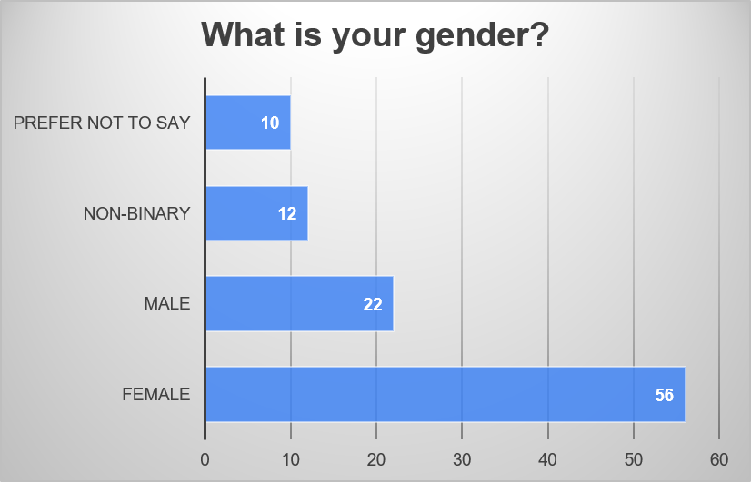
Figure 14: Gender data of the participants
(Source: Created from Survey data)
As revealed by figure 14, 56% of the respondents were female while 22% male participants. In addition 12% identified as non-binary and 10 percent did not wish to state their gender, showing the female category of respondents was the largest.
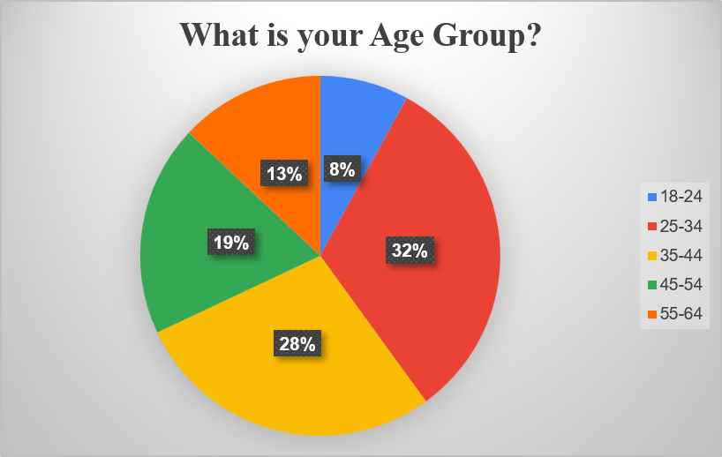
Figure 15: Age group data of the participants
(Source: Created from Survey data)
As seen in figure 15, 32 %of the respondents are in the 25-34 age group and 28% are of 34-44. 19% are 45 to 54 years, 13% are 55 to 64 years and 8% are 18 to 24 years.
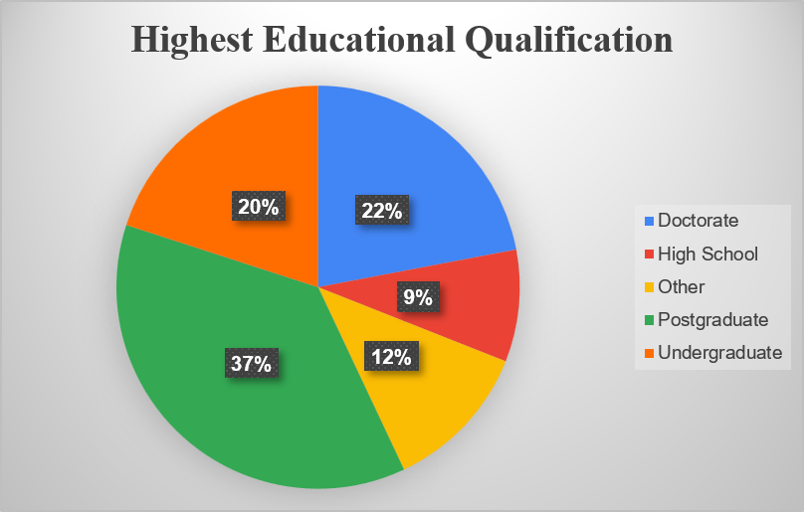
Figure 16: Highest Educational Qualification of the participants
(Source: Created from Survey data)
37% hold postgraduate qualification followed by 22% who had a doctorate, 20% who hold undergraduate degree, 12% had other qualifications and 9% who had taken high school.
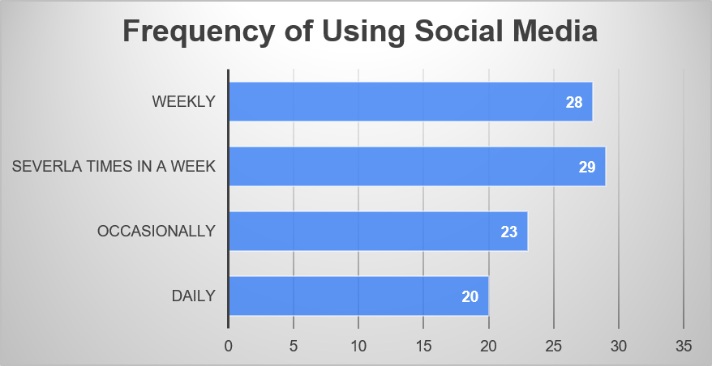
Figure 17: Frequency of social media usage
(Source: Created from Survey data)
As seen in figure 17, 29% used social media a few times each week and 28% once a week. 23% access social media sometimes while 20% accesses it on a daily basis.

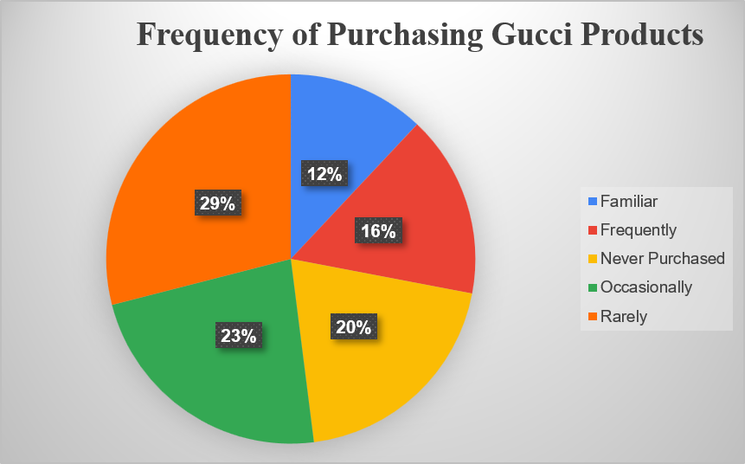
Figure 18: Frequency of Purchasing Gucci Products
(Source: Created from Survey data)
Figure 18 shows that 29% rarely and 23% occasionally buy Gucci products. 20% had never bought any Gucci products, 16% bought frequently and 12% were just familiar with the brand only.
The demographic findings showed that the participants had a diversity and an appropriate sample to study the effect of consumer trust, brand perception, influencers and purchase intentions.

4.2.2 Objective-wise non-demographic
- To study the relationship between the credibility of influencer and consumer perception to purchase in the United Kingdom Gucci.
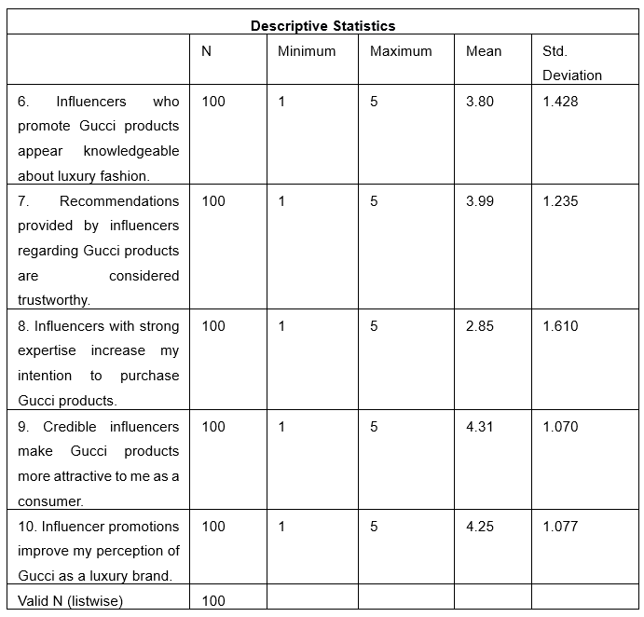
Table 2: Descriptive for Objective 1
(Source: SPSS)
As it can be seen from Table 2, the results obtained through the calculation of the descriptive statistics demonstrate quite a positive attitude towards the effect of the influence on purchase intention. In particular, the scores range from 2.85 to 4.26, which means that the levels of agreement also differ from variable to variable. The statements that can be considered agreeable relate to the effect of influencers on purchase intention (Mean = 3.80–3.99; SD = 1.235–1.428). The lowest score is an indicator that the level of agreement with the statement about the effect of influencers' expertise on purchase intention is rather low (Mean = 2.85; SD = 1.610). On the contrary, the statement about the enhancement of the attractiveness of the Gucci brand due to the credibility of the influencers has the highest score (Mean = 4.21; SD = 1.070), as well as the statement regarding the perception of the brand (Mean = 4.26; SD = 1.077).
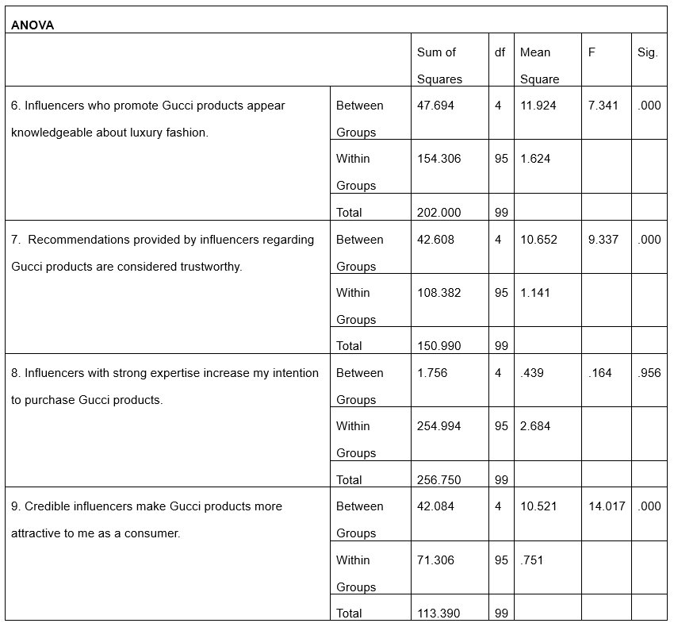
Table 3: ANOVA analysis for Objective 1
(Source: SPSS)
The results of the ANOVA test are demonstrated in Table 3. It can be noted that statistically significant differences exist in the perceptions of the aspects discussed in this research. Differences in perceptions can be detected in regard to the knowledge of the influencers (F = 7.341, p < 0.001), trustworthiness of the influencers (F = 9.337, p < 0.001), and the attractiveness generated due to the credibility of the influencers (F = 14.717, p < 0.001). On the contrary, the effect of the influencers' expertise on purchase intention is not statistically significant (F = 0.514, p = 0.966). Therefore, the results of the ANOVA test demonstrated statistically significant differences in all aspects of influencer credibility.

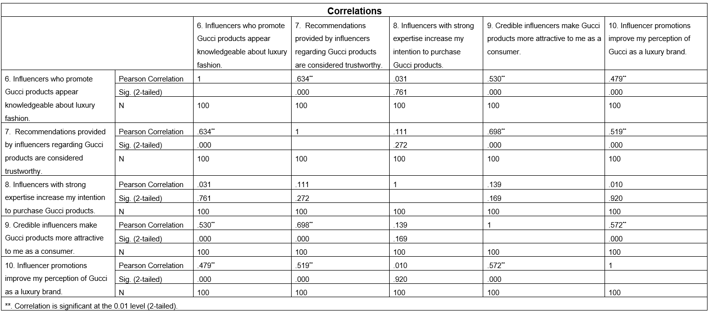
Table 4: Correlations for Objective 1
(Source: SPSS)
Pearson correlation revealed positive correlations between the variables. In particular, the knowledge of the influencers was positively correlated with trustworthy recommendations (r = .356), brand perception (r = .533), and brand image (r = .497). Similarly, trustworthy recommendations were positively correlated with brand perception (r = .606) and brand image (r = .687).
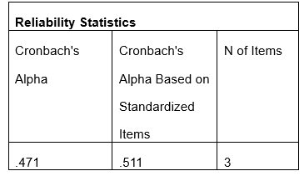
Table 5: Reliability Testing for objective 1
(Source: SPSS)
The results of the reliability test using Cronbach's Alpha are showcased in Table 5. As per the results of measurement from Objective 1, the coefficient of Cronbach's Alpha equals 0.471, while after the standardization it comes 0.511. Consequently, the results reveal that there are relatively low levels of internal consistency compared to the threshold of 0.70. Hence, the reliability of the measurement scale is questionable when measuring the consistency of the responses for Objective 1.
- To explore the influence of influencer marketing on the perception of the Gucci brand by the consumers.
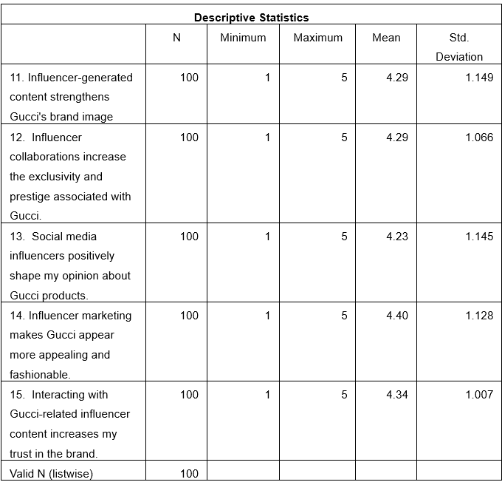

Table 6: Descriptive for Objective 2
(Source: SPSS)
According to the table of descriptive statistics, the attitudes of consumers toward influencer marketing and its effect on the brand perception of Gucci are rather positive. The mean scores range from 4.26 to 4.40, which means that the level of agreement is rather high. The highest mean score is associated with the statement "Influencer collaboration makes Gucci more attractive and fashionable" (Mean = 4.40, SD = 1.128), followed by the statement "Consumer trust is raised due to engagement with influencer content" (Mean = 4.34, SD = 1.007). Furthermore, the consumers were rather positive about the fact that influencer content affects brand image (Mean = 4.29, SD = 1.149) and the image of exclusiveness and prestige of Gucci (Mean = 4.26, SD = 1.066). Consequently, it may be said that the study results prove the fact that the consumers have positive attitudes toward influencer marketing in relation to brand perception.
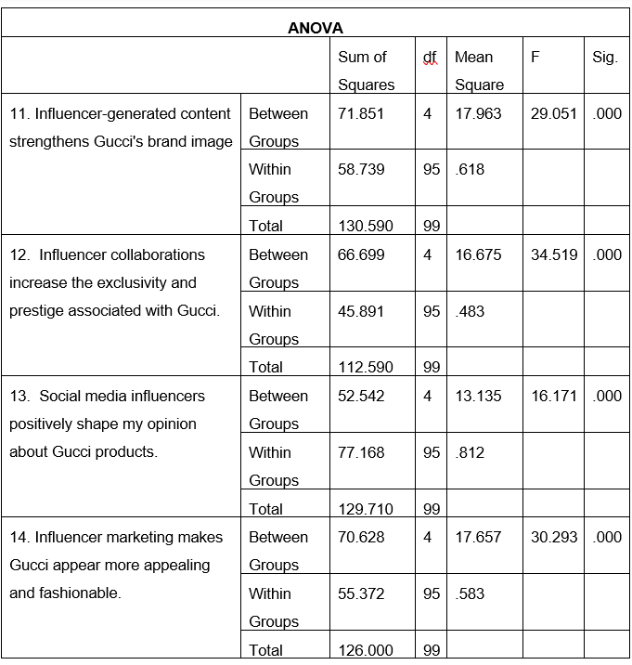
Table 7: ANOVA analysis for Objective 2
(Source: SPSS)
Table 7 presented below represents the results of the analysis of variance in regards to Objective 2. It may be noted that all four variables present statistically significant results (p < 0.001), which means that the differences in the evaluation of the respondents are statistically significant. The highest F-value belongs to the statement "Influencer collaboration makes the brand more prestigious" (F = 34.519), followed by the statement "Influencer-generated content improves the brand image" (F = 29.050), "Influencer marketing makes Gucci more attractive and trendy" (F = 30.293), and "Social media influencers shape opinions about Gucci" (F = 16.710). Thus, it may be said that the results of the ANOVA analysis prove the fact that there are statistically significant differences in all Objective 2 variables.
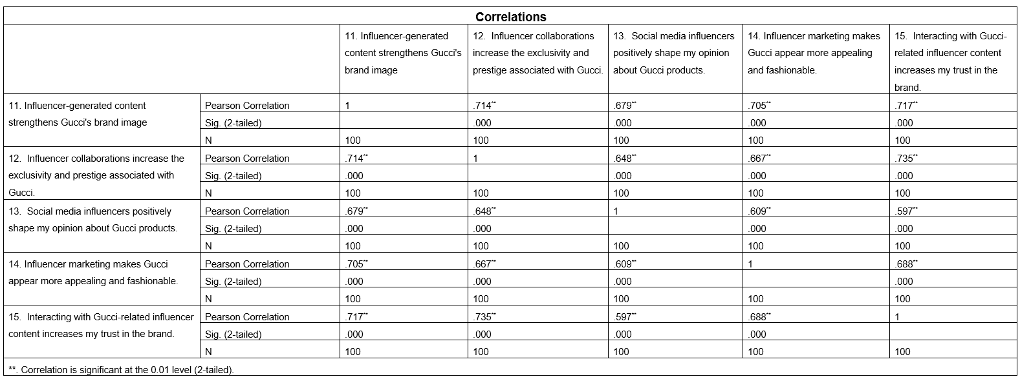
Table 8: Correlations for Objective 2
(Source: SPSS)
According to the results of the Pearson correlation analysis, it is evident that all the variables, which include such variables as influencer-generated content, consumer trust, influencer collaboration, social media influence, and brand perception, present statistically significant positive relationships (p < 0.001). No negative correlations were revealed, which means that all the mentioned variables have positive relationships. Hence, it may be concluded that the study results show positive relationships between all Objective 2.
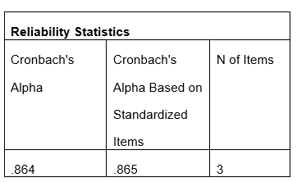
Table 9: Reliability Testing for objective 2
(Source: SPSS)
Table 9 presented below shows the results of the reliability test of the Objective 2 measurement items. It is evident from the table that the values of Cronbach's Alpha equal to 0.864 and 0.865 (standardized) are higher than the threshold value of 0.70. This means that the internal consistency of the questionnaire items is excellent. Therefore, it may be stated that the measurement scale is reliable.
- To find out the role played by social media engagement in the development of consumer trust and intentions to buy Gucci products
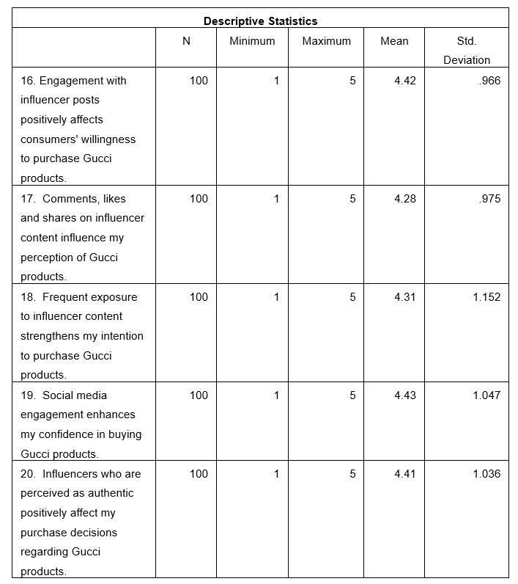
Table 10: Descriptive for Objective 3
(Source: SPSS)
As it is evident from the table of descriptive statistics presented below, consumers have rather positive attitudes toward social media engagement and its effect on consumer trust and purchase intention of Gucci products. The mean scores range from 4.28 to 4.43, which means that the level of agreement with all the variables is high. The highest mean score is related to the variable "Improvement of purchase confidence through social media engagement" (Mean = 4.43, SD = 1.047), followed by the variable "Increasing purchase intention through engagement with the influencer's content" (Mean = 4.42, SD = 0.966), and "Positive influence of influencers on purchase intentions" (Mean = 4.41, SD = 1.036). The respondents agreed that the influencer's content positively affects purchase intention (Mean = 4.31, SD = 1.152) and affects the perceptions of Gucci products (Mean = 4.28, SD = 0.975). In general, the study results indicate the presence of positive perceptions of social media engagement.
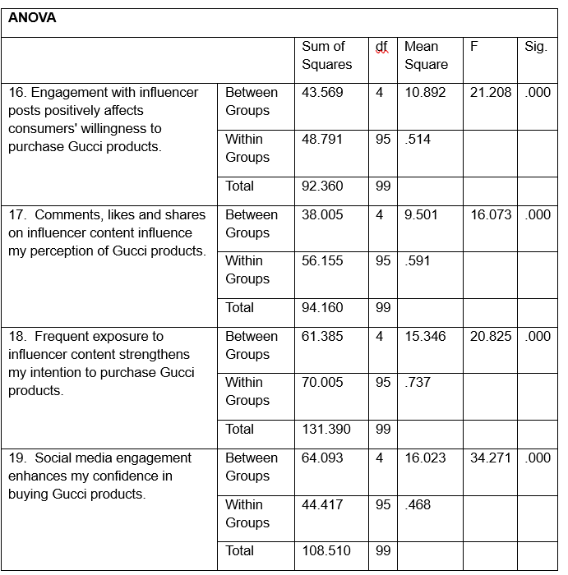
Table 11: ANOVA analysis for Objective 3
(Source: SPSS)
Table 11 presented below represents the results of ANOVA analysis in regard to Objective 3. It may be said that all the variables present statistically significant results (p < 0.001), which means that the differences in the evaluation of the respondents are statistically significant. The highest F-value is associated with the variable "Improvement of purchase confidence through social media engagement" (F = 34.271), followed by the variable "Engagement with the influencer posts increasing purchase intention" (F = 21.208), "Frequent exposure to influencer content influencing purchase intention" (F = 20.825), and "Comments, likes, and shares impacting the perception of the product" (F = 16.073). Thus, it may be concluded that the ANOVA results prove the fact that there are statistically significant differences in all Objective 3 variables.
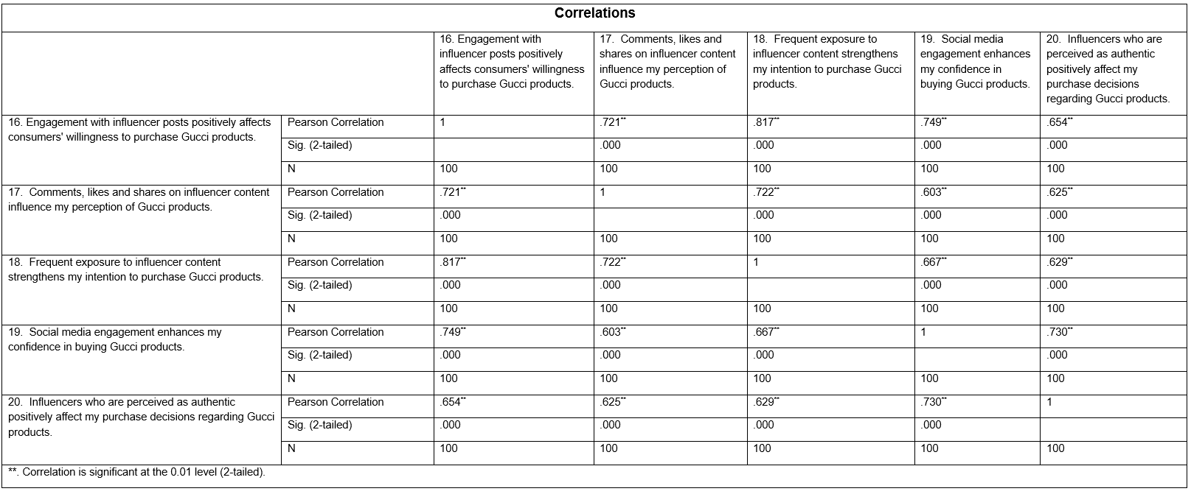
Table 12: Correlations for Objective 3
(Source: SPSS)
According to the results of the Pearson correlation analysis, it may be stated that all the variables, which are related to social media engagement, present statistically significant positive relationships (p < 0.001). Engagement with the influencer content positively correlates with purchase intention, perceptions of Gucci products, purchase confidence, and decisions.
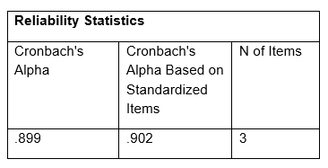
Table 13: Reliability Testing for objective 3
(Source: SPSS)
Table 13 presented below shows the results of the reliability test in regard to the Objective 3 measurement items. As it is evident from the table, the values of Cronbach's Alpha equal to 0.899 and 0.902 (standardized) are higher than the threshold value of 0.70. This means that the internal consistency of the questionnaire items is excellent.

4.3 Chapter Summary
The findings and findings analysis of the primary survey of the Gucci customers in the UK was provided in this chapter. The statistical results showed the trend of the respondents' attitudes and purchase intentions, and the quantitative relationship between the variables in the study. The analysis did not draw more general conclusions, but remained focused on explaining the results of the survey. The findings of these are presented and discussed in the next chapter along with the research problems, theories and literature.

Chapter 5: Analysis

5.1 Introduction
In this chapter, the findings of Chapter 4 will be discussed critically in the context of research questions and objectives, the existing literature and the theoretical framework presented in Chapter 2. Apart from the statistical findings, the significance of the findings will be analyzed in comparison with the previous empirical studies and the theories, including Source Credibility Theory, Source Attractiveness Theory, Social Influence Theory and Theory of Planned Behaviour. In addition, similarities and differences in the literature will be revealed in order to proceed to implications.

5.2 Research Question based Analysis
- How can the credibility of influencers influence consumers' purchase intentions regarding Gucci products in the United Kingdom?
The results have shown that the credibility of influencers is the key factor that influences consumers' purchase intention related to Gucci products in the UK. Consumers positively assessed credible and trustworthy influencers, which indicates that credibility is a significant factor in creating positive consumer evaluations of luxury fashion brands. Although the positive associations between the credibility of influencers and consumers' purchase intention were revealed in Chapter 4, the discussion of the findings has indicated that the role of credibility in the process of influencing consumers is mainly connected with creation of consumers' confidence in the brand. Therefore, the findings have proved the idea that credibility is an important element of influencer marketing, especially in the luxury fashion industry, as consumers need reliable and authentic information prior to making a purchase.
The findings have been also confirmed by the study of Sesar et al. (2022), who have shown that the dimensions of influencer credibility, such as expertise and trustworthiness, have a significant impact on consumers' attitudes towards the products being promoted. Moreover, Zhao et al. (2024) have found out that consumers tend to pay more attention to the products recommended by credible influencers. Thus, the current findings have confirmed the previous studies, indicating that consumers prefer influencers who are seen as knowledgeable and credible when evaluating Gucci products. This means that it is crucial to select influencers who have credible expertise, rather than popularity or the number of followers. However, the findings have also revealed that influencer expertise is not sufficient for increasing consumers' purchase intention. Despite the fact that consumers understood the importance of experts, the association between the expertise and consumers' purchase intention appeared to be comparatively weaker than other dimensions of credibility. This finding has confirmed the argument put forward by Helme (2023) that the effect of credibility depends on the product category and purchasing context. Luxury fashion products need more financial investment and symbolical value than regular consumer goods. Thus, along with the recommendations from influencers, consumers can evaluate brand heritage. Furthermore, credibility of influencers should be considered the factor determining consumer purchase intentions.
Moreover, the results of the current research prove the Source Credibility Theory, which indicates that the messages coming from credible, reliable and knowledgeable sources are more persuasive than those messages coming from less credible sources. Correlation between the credibility of influencers and consumer perceptions proves this theoretical approach. At the same time, relatively low correlation between the expertise and consumer purchase intentions indicates partial validity of this theoretical approach in explaining the behavior of the consumers in the luxury fashion market. Overall, thus, the results of the current research prove the fact that credibility of influencers has a positive effect on the consumer perceptions and purchase intentions of the Gucci products.
- How does influencer marketing impact consumers' perceptions of the Gucci brand?
Results of the research prove that influencer marketing has a positive impact on the consumer perceptions of Gucci brand in the luxury fashion market in the UK. Influencers make the brand more attractive and exclusive in the eyes of the consumers, confirming the positive impact of the influencer marketing on the consumer perceptions of Gucci. Even though influencer marketing does not have any direct impact on the decision-making process of the consumers, it increases the effectiveness of brand communications by making the brand more visible and attractive in the digital environment. Thus, results of the current research prove the importance of appropriate management of collaboration between the luxury brands and influencers.
Results of this research confirm the claims made by Leite et al. (2024) concerning authenticity and engagement of the communication with consumers using the influencer marketing. In addition to this, study conducted by Chen et al. (2024), the influence-generated content has a positive impact on the consumer perceptions of the brand, increasing their engagement and emotional commitment towards it. Positive perceptions of the brand, received during the current research, prove the previous studies, proving the role of the influence-generated content in improving the image of Gucci. In addition, results of this research proved the findings of Jhawar et al. (2023), who found out that the influencer and celebrity collaborations help in increasing the visibility and attractiveness of the luxury brand among young consumers. Therefore, these findings prove the role of influencer marketing in the strategic communications of luxury brands.
However, the results prove that influencer marketing is not the only factor, which influences consumer perceptions of a brand. Even though the consumers positively evaluate the influencer collaborations, the image of the luxury brand is formed by its heritage, quality, exclusivity and reputation. This finding is consistent with the findings of Wang et al. (2024), who found out that the excessive use of the influencer collaborations can negatively affect the perception of the exclusivity and authenticity of the luxury brand. In addition, literature review carried out in Chapter 2 demonstrated the similar issue of the commercialization of the influencer collaborations, as well as possible conflict between the premium positioning of the luxury brand and its excessive exposure on social media.
Moreover, the findings have supported the Social Influence Theory that argues that consumers develop their attitudes and perceptions as a result of interactions with influential people and social networks. The positive brand perceptions found in this study have confirmed that UGC often pushes the brand to create positive perceptions and helps in shaping consumers' perception of Gucci’s image within digital platforms. But the findings suggested that keeping up with the image and anime if a luxury brand demands a balanced approach towards influencer marketing and authenticity. Altogether, this study proved that influencer marketing has delivered an effective study for optimising Gucci's brand precautions among UK consumers.
- How does social media engagement impact consumer trust and purchasing behavior regarding Gucci products?
It can be seen that the obtained results indicate that social media engagement plays an important role in the formation of the consumers' attitudes and purchase intentions regarding Gucci products. Thus, it can be concluded that the process of social media engagement and such actions as views, likes, comments, and sharing content became the key to developing consumer perceptions and purchase intentions due to the trust built through the continuous information exchange. Hence, social media engagement improves the efficiency of the brand promotion because it provides the opportunities for the consumers to interact with the brand and build relationships with it.
The results support the ideas suggested by Liang et al. (2024) as the authors claim that active consumer engagement in the social media interactions increases trust between the brand and consumers due to the information exchange. Furthermore, according to Ao et al. (2023), high levels of social media engagement can help to establish emotional connections with the brand and increase purchase intentions. Thus, the obtained results confirm the previous research findings stating that the active engagement of consumers in the social media communities results in positive consumer attitudes towards the products of Gucci. It means that social media engagement is not only the platform for the promotion of the brand but also provides the opportunities for valuable interactions with the influencer-generated content.
However, it should be noted that the efficiency of social media engagement is measured differently for each consumer. While the respondents have positive attitudes towards the influencer-generated content, the influence of the social media engagement may differ depending on the experience of the consumer, brand recognition, and perception of the sponsored content. According to Hu and Zhu (2022), consumers are becoming more sceptical about influencer marketing due to their awareness of the sponsorship. Thus, the persuasive power of social media engagement decreases in the cases when consumers consider the recommendations as non-authentic and commercial. These results suggest that in order to increase consumer trust, the brand needs to collaborate with credible influencers that will satisfy the requirements of the Gucci brand.
Furthermore, the results coincide with the principles of the Social Influence Theory suggesting that attitudes and behavioural intentions of individuals are shaped during social interactions and networking. The correlation between social media engagement, consumer trust, and purchase intention indicates that consumers are influenced not only by the marketing messages but also by social interactions, peer interaction, and engagement in digital communities. However, in the luxury fashion industry, the involvement of the target customers is associated with using social media. But, there are certain considerations which play a role in making decisions regarding purchasing luxury fashion products. As it follows from the results of the research, involvement in social media is a necessary part of the procedure of influencer marketing as it results in the development of purchase intention while establishing relationship among the brand as well as the consumers.

5.3 Overall Discussion
From the above given study it could be concluded that influencer marketing has imposed a positive impact on the consumer purchasing behavior particularly in terms of the Gucci Products in the UK. The reason that has been identified is too much influencer credibility, brand perception with active social media engagement. These factors have posed a positive impact on the attitude of the consumer while hinting towards the effectiveness of strategy in influencer marketing in luxury fashion. Furthermore, the findings suggested that theoretical perspectives which have been mentioned in Chapter 2 were influencer credibility and social interactions which play a crucial role in the terms of creating consumer attitudes. In contrast, the implementation of influencer marketing strategy can barely replace the traditional branding strategy.

Chapter 6: Conclusion & Recommendations

6.1 Introduction
This chapter provides a brief conclusion about the overall conclusions that were made in terms of research objectives and goals. In this chapter, an overview of the main results obtained during the research process will be provided, the recommendations will be made for Gucci, the limitations of the research will be highlighted, and the suggestions for further research will be offered. At last, this chapter will state the contribution of the research to the field of study.

6.2 Overall Conclusion
The goal of the research was to investigate the effect of influencer marketing on purchase intention and brand perception regarding Gucci products within the luxury fashion market in the UK. Considering the results of the research stated in Chapters 4 and 5, it can be said that the research was successful since it managed to prove that the credibility of the influencer, brand perception, and social media engagement had a positive impact on the purchase intention of consumers. The results showed that the credibility of the influencer positively affects the level of trust of consumers in Gucci products. People are more likely to react positively to the influencers that are considered to be credible (knowledgeable and authentic). However, it should be noted that the credibility factor seems to be insufficient for influencing purchase intention of consumers in case of luxury goods.
Moreover, the findings depicted that influencer generated content has a positive effect upon the perceptions of Gucci because of enhanced attractiveness, prestige and image. Thus, the findings revealed that with an appropriate selection of influential people, it might allow the brand to improve its luxury positions and engage more deeply with the customers. Additionally, the findings also showed that social media engagement plays an important role in changing the purchase intentions of the consumers as it is considered one of the key determinants. Through engagement with the social media allows in trust building and changes the purchase intention towards the Gucci products.
Therefore it could be summarised that influencer marketing is a beneficial strategy for Gucci but it is necessary to use it appropriately. However it should be taken into consideration that influencer marketing needs to complement the luxury branding in order to make sure that there is premium positioning.

6.3 Objective-wise Conclusion
Objective 1: To examine the link between the credibility of influencers and consumers' intentions to buy Gucci products in the United Kingdom.
The objective 1 entailed researching the effect of influencer credibility on the purchase intention of Gucci products. The findings showed that consumers have higher levels of trust in the influencers who are viewed as knowledgeable, credible, and trustworthy. Although credibility has a positive effect on consumers' perceptions, it is not the only one factor that matters. Therefore, the findings confirmed the Hypothesis H1 and supported the idea that influencer credibility positively affects consumers' purchase intentions in the UK luxury fashion market.
Objective 2: To explore the influence of influencer marketing on the perception of the Gucci brand by the consumers.
The objective 2 is all about studying the impact of influencer’s marketing according to consumer’s perception of the Gucci Brand. This has been found out that the content showcased by influencers positively impacts the attractiveness of the brands, exclusivity with image. Altogether, consumer influencer collaborations are the necessary positives of the brand. But it is necessary to keep the content genuine in order to maintain the value of the brand. Thus the findings suggested that Hypothesis H2 showcased the influencer marketing positive hints towards brand perception in the UK luxury fashion industry.
Objective 3: To find out the role played by social media engagement in the development of consumer trust and intentions to buy Gucci products.
The objective 3 entailed examining the effect of social media engagement, trust, and purchase intentions. The findings showed that engagement with the content created by influencers leads to the improvement of consumer trust and purchase intention of Gucci products. Social media engagement might be regarded as an important aspect of influencer marketing since it helps build relationships between consumers and brands in social media. Therefore, the findings confirmed the Hypothesis H3 and proved that social media engagement positively influences consumers' purchase intentions in the UK luxury fashion market.

6.4 Recommendations
The recommendations are listed below,
- When it comes to the selection of influencers for the promotion of the brand image and the company's products, Gucci needs to consider such traits of potential influencers as credibility, expertise, authenticity, and engagement. However, while choosing influencers for the promotion of Gucci, the number of the followers of each influencer should not become the decisive criterion. It was already noted above that the results showed that credible influencers can help to improve the consumers' trust and perception of luxury in the case of Gucci's brand. Therefore, the following criteria should be considered when selecting influencers for Gucci: the relevance of the audience, the quality of content, the engagement level, and similar values (Riboldazzi and Capriello, 2020).
- Second, Gucci should promote the creation of authentic and experience-based content instead of the commercial one. Even though the study has shown that the strategy of the influencer marketing has significantly improved brand perception hence, excessive commercialization can influence the exclusiveness of the luxury brand. Therefore, the influencers should be encouraged to share their experience concerning the products by using storytelling and personalized reviews (Feng et al., 2021).
- Thirdly, the company should focus on the development of the activities in social media that will engage customers. For instance, Gucci could create various interactive campaigns that would include such elements as live-streaming, product launch, behind the scenes content, Q&A, user-generated content, etc.
- Finally, Gucci should constantly evaluate the effectiveness of the influencer collaborations by using data-driven performance metrics. Instead of the number of likes and followers, the company should evaluate the engagement rate, the sentiment of consumers, conversion rate, repeat purchases and brand loyalty (Isen et al., 2026). The constant evaluation will allow Gucci to identify successful collaboration with influencers and adjust ineffective campaigns.

6.5 Limitations of the study
There are certain limitations to the research that need to be taken into consideration when analysing its results. First of all, the use of convenience sampling in the research limits its generalizability because of its non-representativeness. Furthermore, the small sample size could affect the representation of the Gucci consumer population in the UK. Moreover, the cross-sectional research design does not allow for analysing the changes in the consumers' behavior as the information about the opinion of consumers was collected at one point in time. Finally, the research was conducted for one luxury fashion brand and cannot be generalized for other companies. The aforementioned limitations provide the opportunities for future research.

6.6 Future Research
This study is limited only to the consumers of Gucci in the UK using the cross-sectional quantitative research design. The future research could compare multiple luxury fashion brands, such as Louis Vuitton, Chanel and Prada, in order to understand whether the influencer marketing has the same effect on the consumers in different luxury markets. In addition, the qualitative methods of interviews or focus groups would provide a more in-depth understanding of the emotional motives of purchasing luxury items. The future research may examine the impact of the new categories of influencers, such as virtual and artificial intelligence influencers, on luxury fashion marketing.

6.6 Final Chapter Summary
This chapter contains the analysis of the conclusions that can be drawn from the research in regard to its objectives and aims. Several practical recommendations for Gucci were developed based on the results of the research. In addition to that, the limitations of the research and the opportunities for further research were considered. It could be said that overall credibility of influencers, positive brand perception, and social media engagement increase purchase intentions of consumers.

Chapter 7: Reflection
Reflection is an integral part of the research process since it enables researchers to reflect critically on their learning experience. One of the ways how researchers can achieve that is by using Gibbs' Reflective Cycle (1988). This technique of reflection was used to critically evaluate my experience of conducting this dissertation on the influence of influencer marketing on purchase intention of Gucci products in the UK.
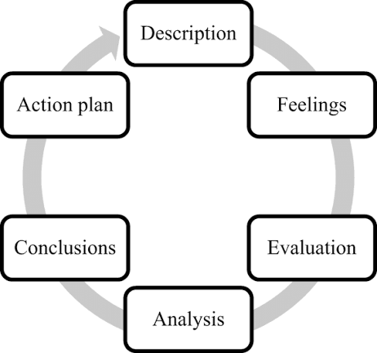
Figure 19: Gibbs' Reflective Cycle
(Source: Sellberg, C. and Wiig, 2020)
Description: This dissertation is aimed at investigating the effect of influencer marketing on the purchase intention and brand perception of Gucci products in the UK luxury fashion market. During the course of this research, I have conducted the literature review, created the questionnaire, collected the primary data from the consumers, analysed the data using Microsoft Excel and SPSS and interpreted the results in the context of previous studies. Additionally, I have analysed such theoretical approaches as Source Credibility Theory, Source Attractiveness Theory, Social Influence Theory and the Theory of Planned Behaviour. The ethical considerations were taken into account during the course of the research and respondents were engaged voluntarily and anonymously.
Feelings
At the beginning, I felt motivated as the research focused on influencer marketing which is an important part of development for the luxury fashion industry. But I was also uncertain about conducting this independent academic research as I do not possess any practical experience for discussing the questionnaire and analysis data with the help of statistical software. Initially, I felt overwhelmed by the interpretation of the descriptive statistics, ANOVA, correlation and reliability analysis. However, after learning about this technique, gradually my confidence increased.
Evaluation
The strong points of this study is: It gave me the opportunity to get firsthand information from the consumers who are associated with Gucci in different years. Additionally, it allows me to build credibility of this study using the parameters such as influencer, brand perception, social media interactions, and purchase intention. Additionally, SPSS usage depicted the statistical results for the objectives and helped answering the research questions with a more reliable way. But I also realized there are limitations in this study as well. Initially, I utilised convenient sampling of smaller size and it prevented me from generalising the results for the population of the entire UK. Another limitation is the cross functional nature of the research which hints towards the gathering consumers opinions at a certain point of time. Changing consumers opinion with fast changing trends of social media could change immediately, the longitudinal research would also offer more valuable information. Despite all these limitations, all the research questions were answered and various findings were revealed in the field of influencer marketing in luxury fashion.
Analysis
I gained knowledge that academic research delves deeper with various other activities other than accumulating information. As per the result of the literature review, I realised that a comparison approach is better than describing the earlier research and it is one of the sole components of research. It has been found out that the majority of the researchers considered that positive effects of influencer assisted in being more critical in the interpretation of the results.
Conclusion
Thus, it could be concluded that this research has helped me become a more efficient researcher, analyser as well as a writer. The experience I developed during conducting the literature review, preparing the research tools, survey administration along with statistical data analysis. I got the understanding how successful research needs a constant critical analysis of the findings rather than just focusing upon the presentation. Despite facing some issues with the methodology, I still gained valuable experiences from it.
Action Plan
Initially I would like to use my statistical skills for analysis for growing and developing with the help of SPSS. These include practices such as regression analysis with structural equation modelling. Secondly, I would utilize better sample size for any further research so that there could be better generalisability. Therefore, such steps would be beneficial for me to foster my academic and professional market research skills.

References
Adefemi, K.O. and Mutanga, M.B. (2025). Localising the Creator Economy: How South African Student Influencers Adapt Global Monetisation Strategies on TikTok and Instagram. Journalism and Media, 6(4), p.181.https://doi.org/10.3390/journalmedia6040181
Ahmad, N., Alias, F.A., Hamat, M. and Mohamed, S.A., (2024). Reliability analysis: application of cronbach's alpha in research instruments. Pioneering the Future: Delving Into E‐Learning's Landscape, pp.114-119. https://appspenang.uitm.edu.my/sigcs/2024-2/Articles/e-Book_SIGCSe-LearningVol8_2024.pdf#page=121
AI, Y.J., KIAT, N.P., JIN, N.Y., TOONG, T.H., SZE, C.C. and YEE, L.J. (2024). Streaming to Success: Amplifying Purchase Intentions Among Malaysian Consumers. International Journal of Economics & Management, 18(1).https://doi.org/10.47836/ijeam.18.1.07
Akande, O.O. and Akin-Odukoya, O.O. (2025). Evaluating the shift from television advertising to influencer marketing in public relations industry in Nigeria. Budapest International Research and Critics Institute-Journal (BIRCI-Journal), 8(2), pp.303-318.https://www.researchgate.net/profile/Omolara-Akin-Odukoya/publication/389952742_Evaluating_the_Shift_from_Television_Advertising_to_Influencer_Marketing_in_Public_Relations_Industry_in_Nigeria/links/67da70e57c5b5569dcc101f9/Evaluating-the-Shift-from-Television-Advertising-to-Influencer-Marketing-in-Public-Relations-Industry-in-Nigeria.pdf
Alinikula, O. and Larsson, A. (2025). When the Influencer Becomes the Brand: Exploring Trust and Reputational Recovery through Perceived Authenticity. https://www.diva-portal.org/smash/get/diva2:1964496/FULLTEXT01.pdf
Ao, L., Bansal, R., Pruthi, N. and Khaskheli, M.B. (2023). Impact of social media influencers on customer engagement and purchase intention: A meta-analysis. Sustainability, 15(3), p.2744.https://doi.org/10.3390/su15032744
Bayramova, A. and Edwards, D.J., (2026). A study of objectivity and subjectivity in research methodology selection. Quality & Quantity, 60(2), pp.5905-5931. https://link.springer.com/article/10.1007/s11135-025-02517-9
Bayuo, J., Nyande, F.K., Awunyo, W. and Akpalu, E (2025). The longitudinal qualitative research design in nursing, health, and social care research: philosophy, methodology, and methods. BMC Medical Research Methodology. https://doi.org/10.1186/s12874-025-02736-6
Bell, E., Harley, B. and Bryman, A (2022). Business research methods. Oxford university press. https://books.google.co.in/books?hl=en&lr=&id=hptjEAAAQBAJ&oi=fnd&pg=PP1&dq=Bell,+Bryman+and+Harley,+2022+&ots=Ddrg25A0Xy&sig=f7vPkc3znu_xzBT9t377oYKPhFk&redir_esc=y#v=onepage&q=Bell%2C%20Bryman%20and%20Harley%2C%202022&f=false
Benichou, J. and Maindron, J. (2024). What is the impact of influencers on the purchase intention of the luxury fashion brands by French generation Z?. https://www.theseus.fi/handle/10024/856814
Cartwright, S., Liu, H. and Davies, I.A. (2022). Influencer marketing within business-to-business organisations. Industrial Marketing Management, 106, pp.338-350.https://doi.org/10.1016/j.indmarman.2022.09.007
Chen, Y., Ma, Y. and Xu, J., (2022). Research on the Marketing Strategy of the Fashion Luxury Industry in the Post-epidemic Era——Taking GUCCI as a Case. 2022. http://166.62.7.99/conferences/LNEMSS/FMESS%202022/Y1215.pdf
Chen, Y., Qin, Z., Yan, Y. and Huang, Y. (2024). The power of influencers: how does influencer marketing shape consumers’ purchase intentions?. Sustainability, 16(13), p.5471.https://doi.org/10.3390/su16135471
Ciunova-Shuleska, A.N.I.T.A. (2022). Source Credibility Theory Applied to Influencer Marketing. Economic Development, 71.https://www.researchgate.net/profile/Tatjana-Spaseska-3/publication/366642512_SMALL_AND_MEDIUM_SIZED_ENTEPRISES_DURING_THE_COVID-19_PANDEMIC_CRISIS_-PROBLEMS_AND_CHALLEGES/links/63aee815097c7832ca799059/SMALL-AND-MEDIUM-SIZED-ENTEPRISES-DURING-THE-COVID-19-PANDEMIC-CRISIS-PROBLEMS-AND-CHALLEGES.pdf#page=71
Collier, B., Flynn, G., Stewart, J. and Thomas, D. (2022). Influence government: Exploring practices, ethics, and power in the use of targeted advertising by the UK state. Big data & society, 9(1), p.20539517221078756.https://journals.sagepub.com/doi/pdf/10.1177/20539517221078756
Drego, Adelia. (2024). On Early Product Development in the Context of Aircraft Thermal Management Design. https://doi.org/10.3384/9789180757621
Duffek, B., Eisingerich, A.B., Merlo, O. and Lee, G. (2025). Authenticity in influencer marketing: how can influencers and brands work together to build and maintain influencer authenticity?. Journal of Marketing, 89(5), pp.21-46.https://journals.sagepub.com/doi/pdf/10.1177/00222429251319786
Duh, H.I. and Thabethe, T. (2021). Attributes of Instagram influencers impacting consumer brand engagement. International Journal of Internet Marketing and Advertising, 15(5-6), pp.477-497. https://doi.org/10.1504/IJIMA.2021.10034199
Elgeddawy, M. and Abouraia, M. (2024) July. Pragmatism as a research paradigm. In European Conference on Research Methodology for Business and Management Studies (pp. 71-74). Academic Conferences International Limited. https://books.google.co.in/books?hl=en&lr=&id=pj8XEQAAQBAJ&oi=fnd&pg=PA71&dq=pragmatism+philosophy&ots=C3LA8mPzCY&sig=gN7eaPG_069WbySXuVRAQxHGuYY&redir_esc=y#v=onepage&q=pragmatism%20philosophy&f=false
Feng, Y., Chen, H. and Kong, Q. (2021). An expert with whom I can identify: The role of narratives in influencer marketing. International Journal of Advertising, 40(7), pp.972-993. https://www.researchgate.net/profile/Yang-Feng-36/publication/344889930_An_expert_with_whom_I_can_identify_The_role_of_narratives_in_influencer_marketing/links/6171a915750da711ac67669d/An-expert-with-whom-I-can-identify-The-role-of-narratives-in-influencer-marketing.pdf
Field, A., 2024. Discovering statistics using IBM SPSS statistics. Sage publications limited. https://books.google.co.in/books?hl=en&lr=&id=jDrVEAAAQBAJ&oi=fnd&pg=PA5&dq=IBM+SPSS+Statistics+for+data+analysis&ots=dbBz3cxLJs&sig=Ccsa4OIrrnERwH12XH6L2hz46hc&redir_esc=y#v=onepage&q=IBM%20SPSS%20Statistics%20for%20data%20analysis&f=false
Gao, M., Xu, Y. and Yan, M. (2023). Marketing mix strategy in the metaverse: the luxury brands case study. Advances in Economics Management and Political Sciences, 28(1), pp.230-236. . 10.54254/2754-1169/28/20231334
Ha, M.T., (2022). Data collection using online questionnaires in marketing (Vol. 2022). SAGE Publications, Limited. https://dx.doi.org/10.4135/9781529603569
Hamedani, S.S., Lumat, Y., Ann, C., Zainuddin, M.H.B. and Minhat, M.F.B. (2025). Influencer Marketing and Consumer Purchase Decisions in the Fashion Industry: A Comprehensive Analysis. [online] Available at: https://www.researchgate.net/profile/Sharareh-Shahidi/publication/394851132_Influencer_Marketing_and_Consumer_Purchase_Decisions_in_the_Fashion_Industry_A_Comprehensive_Analysis/links/6927d941abe27c41e515eb0a/Influencer-Marketing-and-Consumer-Purchase-Decisions-in-the-Fashion-Industry-A-Comprehensive-Analysis.pdf.
Helme, E. (2023). The role of authentic communication on perceived information credibility in influencer marketing.https://lutpub.lut.fi/bitstream/handle/10024/166831/Masters_Thesis_Helme_Elmeri.pdf?sequence=1&isAllowed=y
Hu, S. and Zhu, Z. (2022). Effects of social media usage on consumers’ purchase intention in social commerce: a cross-cultural empirical analysis. Frontiers in Psychology, 13, p.837752. https://doi.org/10.3389/fpsyg.2022.837752
Isen, B., Moyosore, F.O., Adetola, T.P., Lawal, A.K., Amuna, M., Ntim, P.Y. and Kwarteng, R.A. (2026). The Impact of Customer Analytics on Sales Funnel Conversion and Customer Retention in the E-Commerce Industry. Asian Journal of Economics, Business and Accounting, 26(1), pp.207-224. https://www.researchgate.net/profile/Prince-Ntim/publication/399732256_The_Impact_of_Customer_Analytics_on_Sales_Funnel_Conversion_and_Customer_Retention_in_the_E-Commerce_Industry/links/69aa45721a0d8b29ca70fcc1/The-Impact-of-Customer-Analytics-on-Sales-Funnel-Conversion-and-Customer-Retention-in-the-E-Commerce-Industry.pdf
Jamali, Ahmad. (2024). EFFECT OF BRAND IMAGE ON YOUNG CUSTOMERS IN DEVELOPING ECONOMIES. 12. 2347-6915. https://www.researchgate.net/publication/381301912_EFFECT_OF_BRAND_IMAGE_ON_YOUNG_CUSTOMERS_IN_DEVELOPING_ECONOMIES
Janiszewski, C. and Van Osselaer, S.M., (2022). Abductive theory construction. Journal of consumer psychology, 32(1), pp.175-193. https://doi.org/10.1111/puar.13856
Jhawar, A., Kumar, P. and Varshney, S. (2023). The emergence of virtual influencers: a shift in the influencer marketing paradigm. Young Consumers, 24(4), pp.468-484. http://dx.doi.org/10.1108/YC-05-2022-1529
Karunasingha, A. and Abeysekera, N., (2022). The mediating effect of trust on consumer behavior in social media marketing environments. South Asian Journal of Marketing, 3(2), pp.135-149. https://doi.org/10.1108/SAJM-10-2021-0126
Khan, S.A., Al Shamsi, I.R., Ghilan Al Madhagy, T.H. and Anjam, M. (2022). When luxury goes digital: does digital marketing moderate multi-level luxury values and consumer luxury brand-related behavior?. Cogent Business & Management, 9(1), p.2135221.https://doi.org/10.1080/23311975.2022.2135221
Kim, J. and Kim, M. (2022). Rise of social media influencers as a new marketing channel: Focusing on the roles of psychological well-being and perceived social responsibility among consumers. International journal of environmental research and public health, 19(4), p.2362.https://doi.org/10.3390/ijerph19042362
Kircher, R. and Zipp, L., (2022). Questionnaires to elicit quantitative data. Research methods in language attitudes, pp.129-144. https://books.google.co.in/books?hl=en&lr=&id=y-ZwEAAAQBAJ&oi=fnd&pg=PA129&dq=Quantitative+data+&ots=D6lmkNH4fE&sig=aavXTlutUCOfamdjFhdT6tw_SoE&redir_esc=y#v=onepage&q=Quantitative%20data&f=false
Kistruck, G.M. and Slade Shantz, A., (2022). Research on grand challenges: Adopting an abductive experimentation methodology. Organization Studies, 43(9), pp.1479-1505. https://doi.org/10.1177/01708406211044886
Kumar, S. and Ujire, D.K., (2024). Inductive and deductive approaches to qualitative research. International Journal of Multidisciplinary Educational Research, 13(1), pp.58-63. https://ijmer.s3.amazonaws.com/pdf/volume13/volume13-issue1(4)/9.pdf
Leite, F.P., Pontes, N. and Schivinski, B. (2024). Influencer marketing effectiveness: giving competence, receiving credibility. Journal of Travel & Tourism Marketing, 41(3), pp.307-321. https://doi.org/10.1080/10548408.2024.2317748
Liang, S.Z., Xu, J.L. and Huang, E. (2024). Comprehensive analysis of the effect of social influence and brand image on purchase intention. Sage Open, 14(1), p.21582440231218771. https://doi.org/10.1177/21582440231218771
Lim, W.M. (2022). Toward a theory of social influence in the new normal. Activities, Adaptation & Aging, 46(1), pp.1-8. https://doi.org/10.1080/01924788.2022.2031165
Liu, S. and Liu, C., (2025). Mapping the digital transformation in the fashion industry: the past, present and future. Journal of Fashion Marketing and Management: An International Journal, 29(7), pp.1292-1319.https://www.researchgate.net/profile/Sujun-Liu/publication/393319616_Mapping_the_digital_transformation_in_the_fashion_industry_the_past_present_and_future/links/686fda5cae516743559ba701/Mapping-the-digital-transformation-in-the-fashion-industry-the-past-present-and-future.pdf
Lu, M. (2024). Innovative Marketing in Luxury Fashion: How Gucci Uses Big Data to Enhance Digital Marketing. Scientific Journal of Economics and Management Research Volume, 6(7). https://pdfs.semanticscholar.org/7e89/f21f3924712f29d393ab46460f12c21250d3.pdf
Lu, M. (2024). Innovative Marketing in Luxury Fashion: How Gucci Uses Big Data to Enhance Digital Marketing. Scientific Journal of Economics and Management Research Volume, 6(7).https://pdfs.semanticscholar.org/7e89/f21f3924712f29d393ab46460f12c21250d3.pdf
Mabkhot, H., Isa, N.M. and Mabkhot, A. (2022) ‘The influence of the credibility of social media influencers (SMIs) on the consumers’ purchase intentions: Evidence from Saudi Arabia’, Sustainability, 14(19), Article 12323. https://doi.org/10.3390/su141912323
Madsen, A. and Mbuyi Tshibangu, S. (2023). The effect of Instagram influencers' messages on millennials' purchase intentions and factors that influence these effects: A qualitative study on the impact of attitude, social norms, behavior control, trust and risk on purchase intention. https://www.diva-portal.org/smash/record.jsf?pid=diva2:1777694
Magano, J., Au-Yong-Oliveira, M., Walter, C.E. and Leite, Â. (2022). Attitudes toward fashion influencers as a mediator of purchase intention. Information, 13(6), p.297.https://doi.org/10.3390/info13060297
Maretha, C (2023). Positivism in philosophical studies. Journal of Innovation in Teaching and Instructional Media, 3(3), pp.124-138. https://pdfs.semanticscholar.org/9e89/639ea6052cf6fe7714717090868f0f2542c9.pdf
Market.us (2024). Influencer Marketing Platform Market size | CAGR of 34%. https://market.us/report/influencer-marketing-platform-market/.
Olivar Aponte, N., Hernández Gómez, J., Torres Argüelles, V. and Smith, E.D., (2024). Fast fashion consumption and its environmental impact: a literature review. Sustainability: Science, Practice and Policy, 20(1), p.2381871. https://doi.org/10.1080/15487733.2024.2381871
Pervin, N. and Mokhtar, M. (2022). The interpretivist research paradigm: A subjective notion of a social context. International Journal of Academic Research in Progressive Education and Development, 11(2), pp.419-428. http://dx.doi.org/10.6007/IJARPED/v11-i2/12938
Rahman, M.A.A. (2017). 'Implementing customer relationship management in governmental organizations,' Research Gate [Preprint]. https://doi.org/10.13140/rg.2.2.30542.15682.
Riboldazzi, S. and Capriello, A. (2020). Identifying and selecting the right influencers in the digital era. In Influencer marketing (pp. 43-58). Routledge. https://www.taylorfrancis.com/chapters/edit/10.4324/9780429322501-5/identifying-selecting-right-influencers-digital-era-sabina-riboldazzi-antonella-capriello
Sansom, R. (2021). Theory of Planned Behavior. [online] Change Theories Collection. Available at: https://ascnhighered.org/ASCN/change_theories/collection/planned_behavior.html.
Saputri, Helen (2024). Education in the View of Realism Philosophy. Journal of Innovation in Teaching and Instructional Media. 4. 177-188. 10.52690/jitim.v4i2.756
Sathibabu, A. and Komarasamy, G. (2022) ‘Physical health issues of the students faced by online learning and its impact on their growth’, Technoarete Transactions on Application of Information and Communication Technology (ICT) in Education, 1(4), pp. 13–18. https://doi.org/10.36647/TTAICTE/01.04.A003
Saunders, M. N. K., Lewis, P., and Thornhill, A. (2019). Research methods for business students (Eighth ed.). Pearson. https://go.exlibris.link/24MYqtdX
Sellberg, C. and Wiig, A.C. (2020) 'Telling Stories from the Sea: Facilitating Professional Learning in Maritime Post-Simulation Debriefings,' Vocations and Learning, 13(3), pp. 527–550. https://doi.org/10.1007/s12186-020-09250-4.
Sesar, V., Martinčević, I. and Boguszewicz-Kreft, M. (2022). Relationship between advertising disclosure, influencer credibility and purchase intention. Journal of Risk and Financial Management, 15(7), p.276.https://doi.org/10.3390/jrfm15070276
Sinaga, N.A., Ningtiyas, F.A., Mahmuzah, R., Zahara, Y. and Fatwa, I., (2023). The Effect of Deductive-Inductive Learning Approach on Creative Thinking Ability and Learning Motivation. Journal of Educational Research and Evaluation, 6(2), pp.123-34. https://d1wqtxts1xzle7.cloudfront.net/105219532/46952_108631_1_PB-libre.pdf?1692776715=&response-content-disposition=inline%3B+filename%3DThe_Effect_of_Deductive_Inductive_Learni.pdf&Expires=1783341596&Signature=OtFTYcKmHPHn8AGXT9hPCHtDUJ3VTFMK8FNh0OVcgfbjN0WuR-i6hV5sAWCeyuujU41YpKwB2xZTQBi8LhqOXBmLQbE1V3ovmokolxCGCRQZa3PxjviCMXYpaOXUdZuSk1kNdXe-L65u~DMUjKl5er4QQHWBXh3uJ49xPQUIxVQpwId0FkwJ5~U-xU6jxGPBlLn02Ow84zmCfSqY9NDvn7BOJk37lyyz4im2eCGsmKb5KTLe6XUUd~qBOK4TmwPGYRs0O0zTz21thTIP3lQInmgHyBjFeNo8Sp~rky0~GCIajYXdMZbG9bwAdEFtsuPnKbs9PNUUrX7clubAtmM~RA__&Key-Pair-Id=APKAJLOHF5GGSLRBV4ZA
Syed, T.A., Mehmood, F. and Qaiser, T. (2023). Brand–SMI collaboration in influencer marketing campaigns: A transaction cost economics perspective. Technological Forecasting and Social Change, 192, p.122580.https://www.sciencedirect.com/science/article/pii/S0040162523002652
Talmatchi, Maxim. (2020). The implications of Proptech on the real estate brokerage. The case study of Dubai, United Arab Emirates. https://www.researchgate.net/publication/342314751_The_implications_of_Proptech_on_the_real_estate_brokerage_The_case_study_of_Dubai_United_Arab_Emirates
Wang, X., Sung, B. and Phau, I. (2024). How rarity and exclusivity influence types of perceived value for luxury. Journal of Brand Management, 31(6), pp.576-592.https://doi.org/10.1057/s41262-024-00359-8
Wolfe, M.T. and Patel, P.C. (2024). Image isn't everything: Personality attractiveness, physical attractiveness, and self-employment earnings. Small Business Economics, 62(2), p.807.https://doi.org/10.1007/s11187-023-00784-0
Wu, Y. (2022, April). Research on the Factors Influencing the Purchasing Behavior of Young Luxury Consumers Case. In 2022 7th International Conference on Social Sciences and Economic Development (ICSSED 2022) (pp. 1338-1343). Atlantis Press. https://doi.org/10.2991/aebmr.k.220405.223
Xu, X. (2023). Influencer marketing with social platforms: Increasing brand awareness and user engagement. Journal of education, humanities and social sciences, 19(19), pp.228-234.https://www.researchgate.net/profile/Ximan-Xu/publication/373760614_Influencer_Marketing_with_Social_Platforms_Increasing_Brand_Awareness_and_User_Engagement/links/6616bb03f7d3fc28743fbfcb/Influencer-Marketing-with-Social-Platforms-Increasing-Brand-Awareness-and-User-Engagement.pdf
Zaiț, A. (2025) Contemporary Marketing in the New Economy and Interconnections. Marketing Theory and Practice in Romania: Model for the Developing World, p.2. https://books.google.co.in/books?hl=en&lr=&id=8WxzEQAAQBAJ&oi=fnd&pg=PA3&dq=contemporary+marketing+research+&ots=quRe8jLB8b&sig=N45nzMGD2BHX74epPqW8yenJ8eI&redir_esc=y#v=onepage&q=contemporary%20marketing%20research&f=false
Zhang, Jiawei. (2025). Luxury Brands' Online Sales Model in Digital Age. Academic Journal of Management and Social Sciences. 13. 851-856. https://doi.org/10.54097/zpmmn659
Zhao, X., Xu, Z., Ding, F. and Li, Z. (2024). The influencers’ attributes and customer purchase intention: The mediating role of customer attitude toward brand. SAGE open, 14(2), p.21582440241250122. https://journals.sagepub.com/doi/abs/10.1177/21582440241250122
Zhou, Z., (2024). Research on Gucci’s business strategies and their implications. Highlights in Business, Economics and Management, 24, pp.74-82. . 24. 743-748. 10.54097/dwtwdf97.

Appendices
Survey form link: https://docs.google.com/forms/d/e/1FAIpQLSc-GSA5G1qFEuhzj-F4IREgC_qn7jMfHRIrjsmEwB2K_cV5Fw/viewform?usp=sharing&ouid=101855448292081817763

Appendix 1: Questionnaire
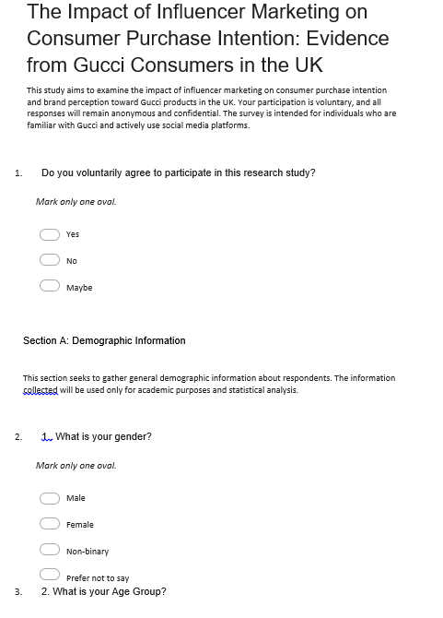
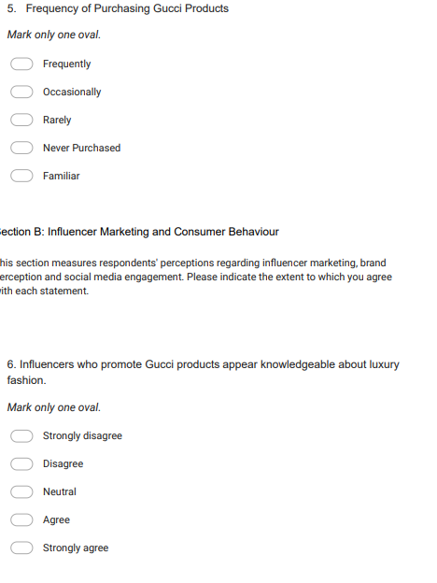
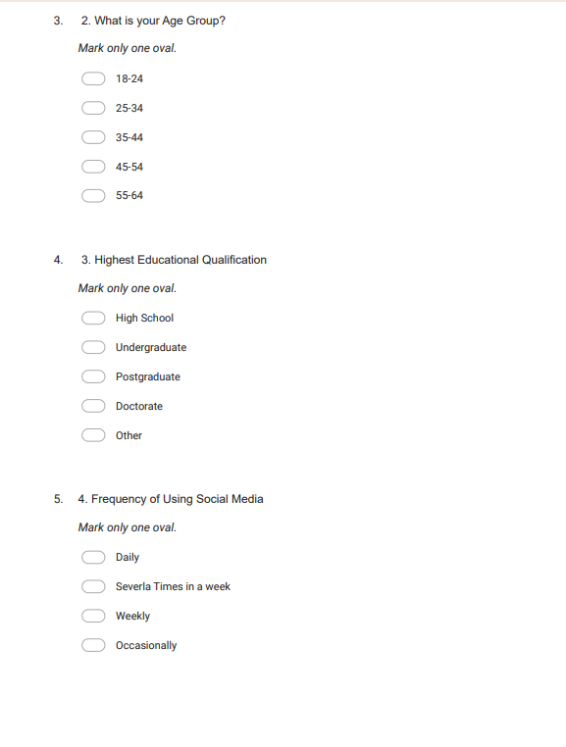

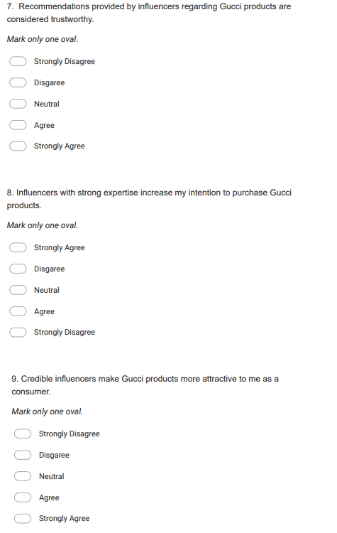
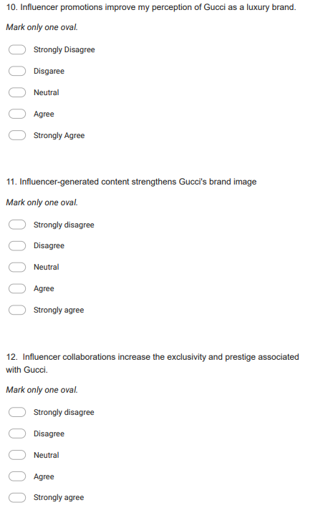
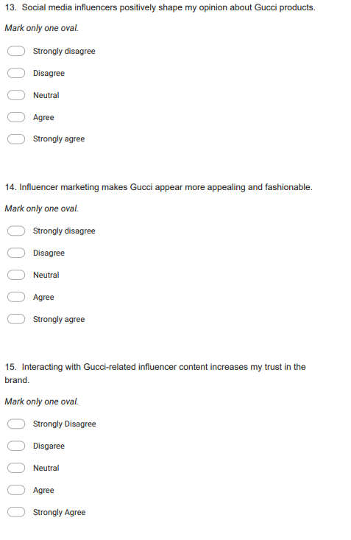
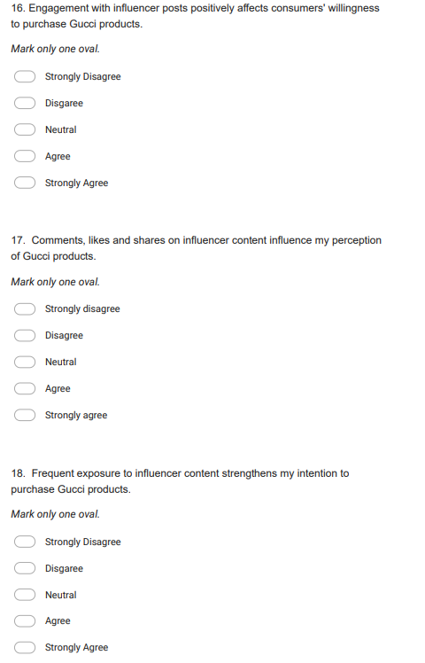
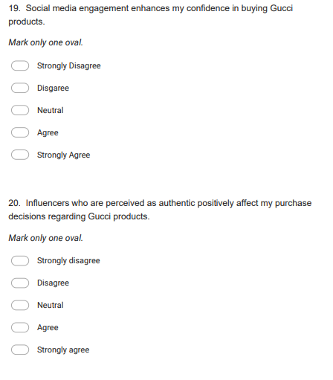

Appendix 2: Sample responses
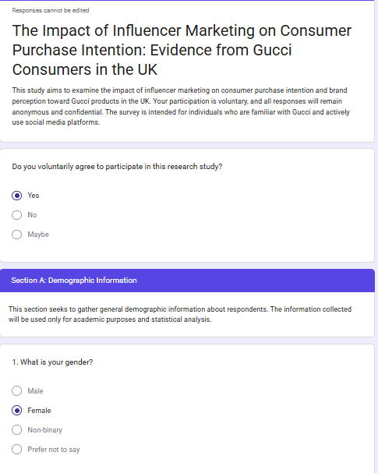
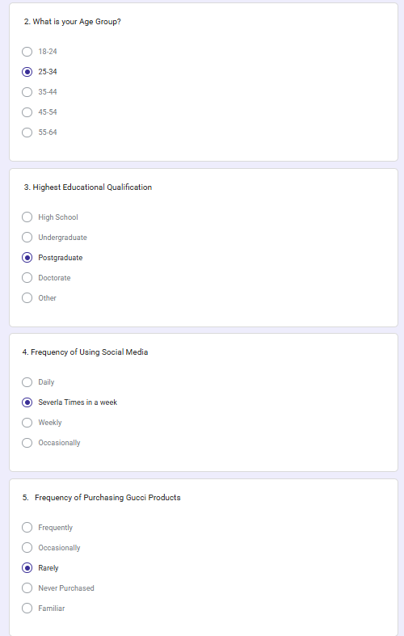
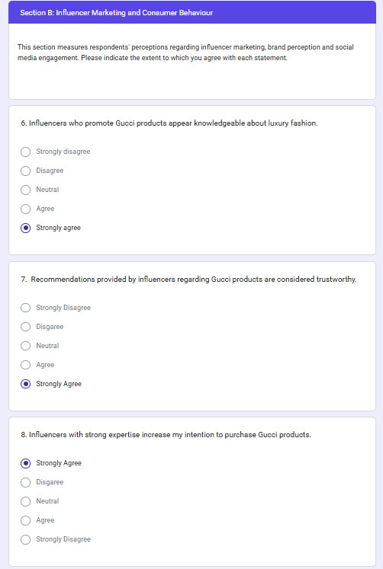
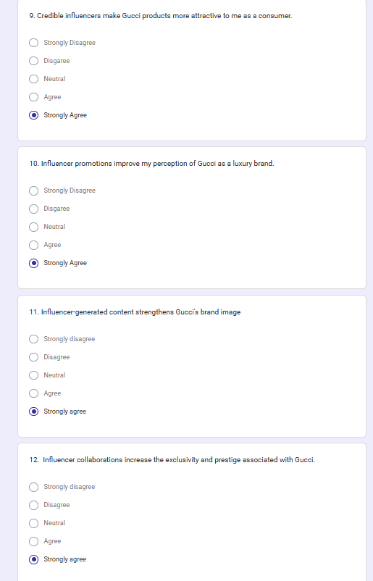
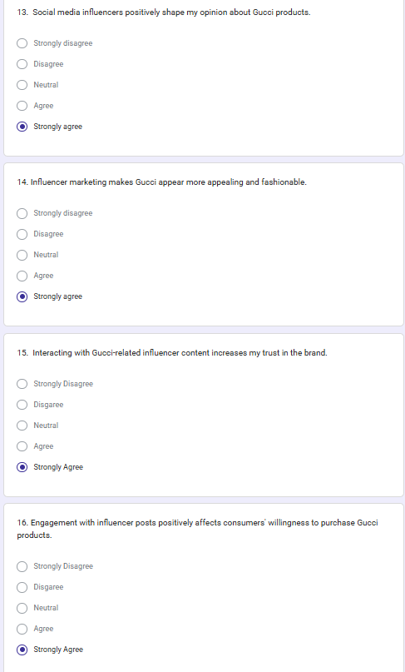
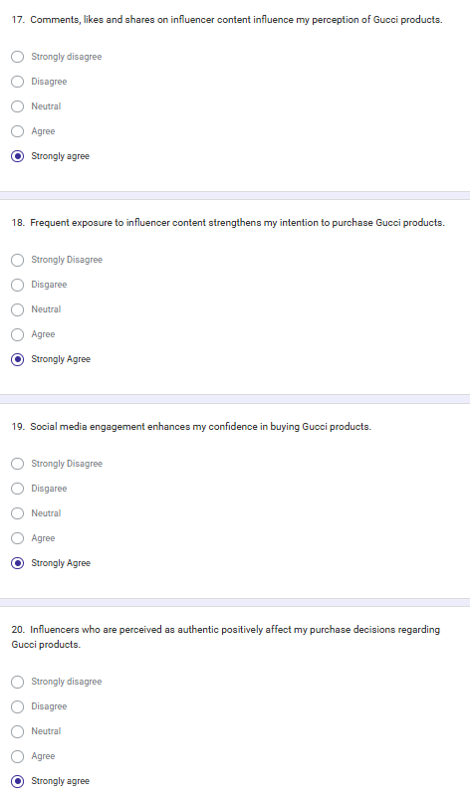

Appendix 3: Supervision Form
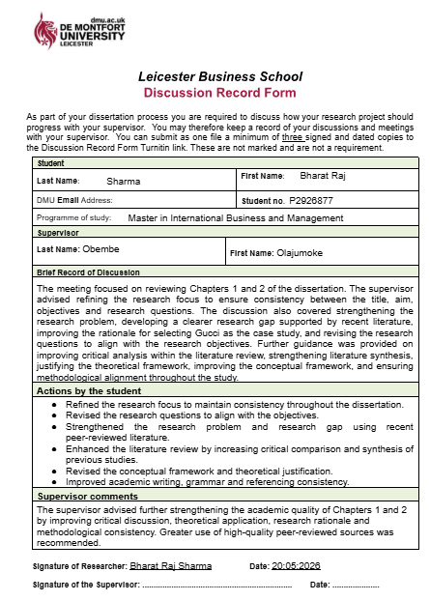

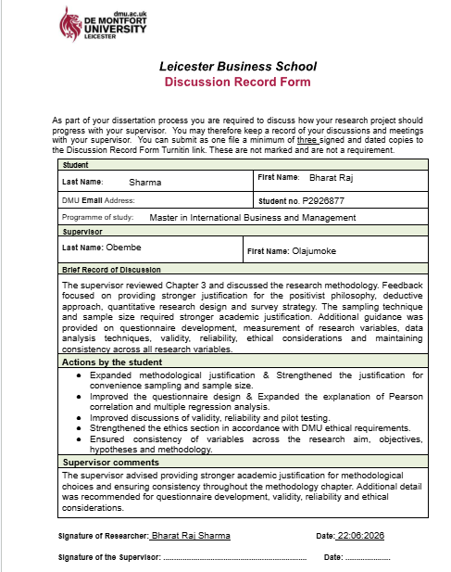
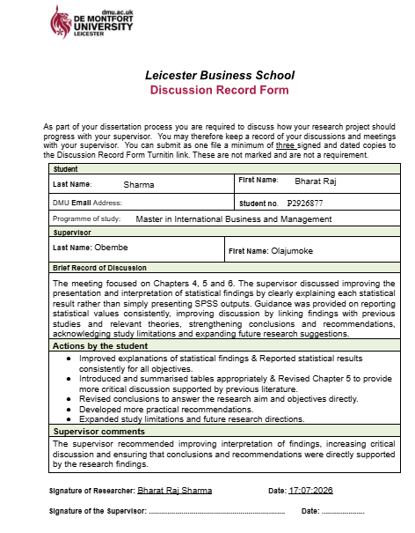

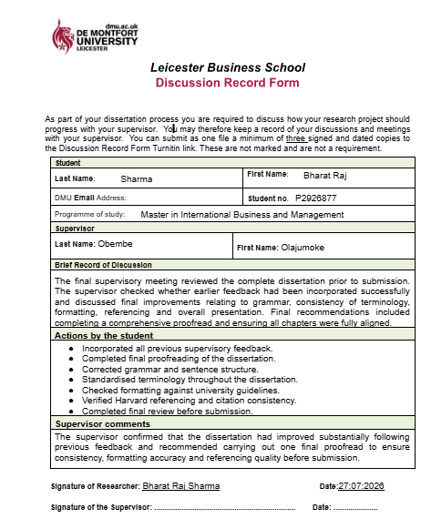

Appendix 4: Ethics Approval Form

AI statement
This research project has been done solely by the student itself. No artificial intelligence has been used for doing this dissertation or automated content generation systems which have been utilized in this preparation, writing along with analysis or editing of the work. All the ideas with written content are the original work of the author that has been supported with academic sources with references.

